Development of Environmental Measures for Assessing Effects of Water Level Changes on Lakes and Wetlands in the Central Florida Water Initiative Area

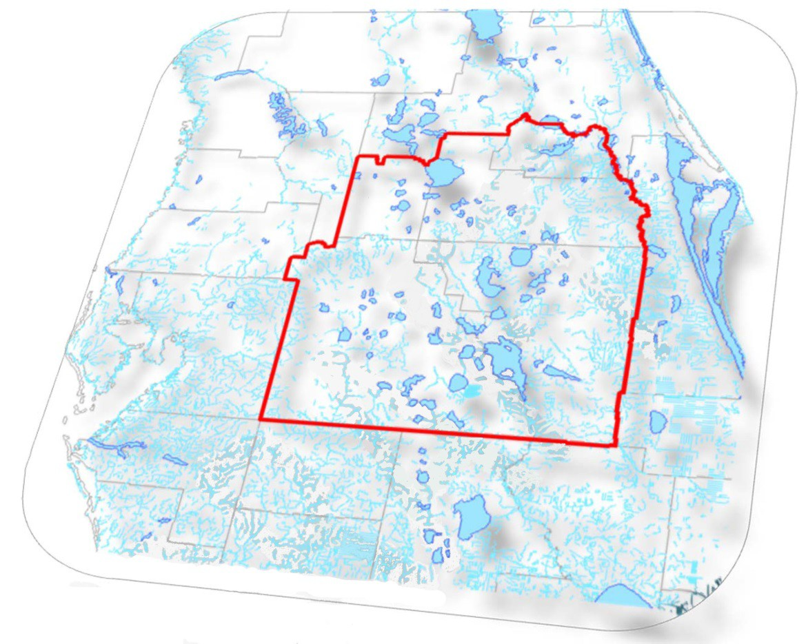

# Central Florida Water Initiative’s Environmental Measures Team

**Final Report**

**November, 2013**

# Acknowledgements

This document was produced by the Environmental Measures Team (EMT) of the Central Florida Water Initiative through a collaborative effort between governmental and stakeholder representatives. The following contributed to the completion of this document:

#### Team Leadership

John Zahina‐Ramos, Ph.D., PWS, South Florida Water Management District David MacIntyre, P.E., D.WRE, Parsons Brinckerhoff

#### Other EMT Authors & Affiliates

Jim Bays, CH2MHILL Shirley Denton, Ph.D., Cardno ENTRIX

Anthony Janicki, Ph.D., Janicki Environmental

Christina Uranowski, PWS, Southwest Florida Water Management District

#### Other Contributors

Marc Ady, South Florida Water Management District

David Carpenter (formerly with the Southwest Florida Water Management District) Sarah Chinault (formerly with the Southwest Florida Water Management District) William Dunn, Ph.D., Dunn, Salsano & Vergara

John Emery, Southwest Florida Water Management District

Robert Fewster (formerly with the St. Johns River Water Management District) Donald Herndon, Southwest Florida Water Management District Kristian Holmberg, St. Johns River Water Management District

Jim Lee, Florida Department of Environmental Protection Don Medellin, CEP, PWS, South Florida Water Management District

Marc Minno, Ph.D. (formerly with the St. Johns River Water Management District) Mary Thomas, P.E., Parsons Brinckerhoff

#### Technical Editing Support

Joel VanArman, South Florida Water Management District

#### Consulting companies and agency staff who provided assistance during this investigation included:

Advanced Ecological Solutions, Inc. (Longwood, FL) Biotechnical Support Services (Tampa, FL)

Earth Balance (Kissimmee, FL) Ecolo~G, Inc. (Jupiter, FL)

E Sciences, Inc. (Altamonte Springs, FL) Lotspeich and Associates, Inc. (Winter Park, FL)

Scientific Environmental Applications, Inc. (Melbourne, FL) Southeast Soil & Environmental Services, Inc. (Fort Pierce, FL)

April Breton, Southwest Florida Water Management District David Carr, Southwest Florida Water Management District

Michael Elion (formerly with the South Florida Water Management District) Jason Godin, South Florida Water Management District

Kenna Harrison, Southwest Florida Water Management District Michael Lopushinsky (formerly with the South Florida Water Management District)

Travis Richardson, St. Johns River Water Management District Catherine Riiska, South Florida Water Management District Chris Sweazy, South Florida Water Management District

Pati Twardosky, Southwest Florida Water Management District

i November, 2013

November, 2013 ii

# Executive Summary

The Central Florida Water Initiative’s (CFWI) Environmental Measures Team (EMT) consisted of scientists from the St. Johns River Water Management District, the South Florida Water Management District, the Southwest Florida Water Management District, and the Florida Department of Environmental Protection, as well as representatives of the public water supply utilities. The EMT was tasked with determining the current status of wetlands with respect to hydrologic stress and alteration, and to develop tools to evaluate modeled future wetland conditions within the CFWI study area. EMT scientists reviewed previous environmental assessments conducted within the region, conducted additional wetland assessments, and performed other tasks in support of the determination of sustainable groundwater withdrawals in the CFWI. The final work product of the EMT was a set of tools that were used by the Groundwater Availability Team to predict likely effects of groundwater withdrawals, as predicted by modeled water levels, on wetland resources.

Field assessments were conducted at 357 wetland sites. In addition to field data, other information and data were acquired, including historic aerial photography time series, soils databases, topographic maps and hydrography maps. Scientists from the three water management districts convened to discuss and review the status of each wetland, to make a determination of wetland stress and to ascertain the presence of hydrologic alterations. Wetlands were identified as being stressed if there was: (1) a multi‐ decadal trend of decreasing water levels seen on historic aerial photography, such as lakes becoming smaller in area, lakes converting to marshes, islands in lakes growing in size; (2) an observed absence of wetland hydrologic indicators during field assessments; (3) evidence of permanently lowered wetland water levels as observed from invasion/establishment of species from drier communities or downward shifts in plant community boundaries; and (4) soil oxidation or loss due to lowered water levels. These stress indicators were selected to exclude the effects of periodic drought or natural periodic rainfall fluctuations and focused on impacts that are associated with non‐natural (outside of normal climatic variability), chronically reduced water levels that have persisted for many years. Forty‐four of the hydrologically isolated field assessment sites had hydrologic monitoring data of sufficient duration, frequency and quality for a quantitative analysis of water level conditions.

The distribution of wetlands (without obvious hydrologic alteration) was mapped to allow visualization of spatial patterns of wetland stress. Results from this analyses showed areas of currently stressed wetlands in ridge settings along the U.S. 27 corridor, in the Southern Water Use Caution Area west of the Lake Wales Ridge (such as the Winter Haven Ridge), in western Orange County and in southeastern Lake County. Most of the wetlands in plains settings, such as the Osceola plain, Green Swamp, southwestern Polk County, and southeastern Osceola County mostly did not show evidence of stress.

Analysis of the potential impact of future groundwater withdrawals included two approaches based on the data set from the 44 assessed wetlands: the examination of modeled future water level changes at these sites and the calculation of the risk for wetland stress occurrence. The first approach examined water level changes at EMT‐assessed wetlands, which were calculated as the difference between a modeled reference condition and future scenarios of 2015, 2025, 2035 and end of permit (EOP) groundwater withdrawals. The second approach was based on an analysis of water level data from the assessed wetlands to compute a statistical relationship between observed stress and observed water level variations. The statistical relationship was used to estimate the probability (or risk) of future changes in wetland stress occurring, based on modeled water level changes between the reference condition and a future groundwater withdrawal scenario. The risk assessment was applied separately to isolated wetlands in plains and ridges physiographic settings because wetland hydrologic conditions in these settings are substantially different due to underlying soils, geology, physiography, typical depths,

iii November, 2013

and other factors. Statistical analyses were performed, which indicated that the characteristics of the 44 sampled wetlands were representative of all isolated wetlands in the CFWI and that the data used were appropriate for their application.

Water table level changes between the modeled reference condition and 2015 scenario were mostly negligible on the plains setting. As a result, changes in the number and acreage of stressed plains wetlands were also negligible. However, water table levels in some ridge wetlands along the U.S. 27 corridor, in western Orange County, southeastern Lake County, and eastern Polk County had decreased, which resulted in an increase in the number and acreage of stressed ridge wetlands. Under the modeled 2015 scenario, approximately 25 percent of assessed wetlands had water table levels lowered by 0.2 to 1.0 ft. Five assessed wetlands (1 percent of assessed sites) had water levels lowered by 1 ft. or more. However, not all wetlands had stable or declining water level trends. Near southeastern Lake, northeastern Polk and northwestern Osceola counties, water levels increased in several assessed wetlands, some of which had been identified as stressed during field studies.

Under the modeled 2025, 2035 and EOP simulations, surface water levels at assessed wetlands decreased substantially from the reference condition, with a corresponding increase in wetland stress response. Although water level decreases were projected to occur in the same areas seen in the 2015 simulation, the spatial extent of wetlands that would be stressed under the modeled conditions increased. In the 2025 simulation, surface water levels declined by 1 ft. or more in 58 assessed wetlands (17 percent of wetland assessment sites). The modeled 2035 and EOP conditions showed little difference in outcomes between the two model runs. In these scenarios, approximately 30 percent of assessed wetlands had surface water levels lowered 0.2 to 1.0 ft. (as compared to the reference condition) and approximately one quarter of assessed wetlands (40‐50 sites) had surface water levels lowered by 1.0 ft. or more. Results from the assessment to determine the acreages of wetlands that are projected to be stressed are shown in Figure ES‐1.

7

6

5

4

3

2

1



80,000

0,000

0,000

0,000

0,000

0,000

0,000

2005

2015

2025

2035

EOP

0,000

0

Plains

Ridge SAS

Ridge UFA

Acres of Stressed Wetlands

**Figure ES‐1. Results from the risk assessment. Vertical axis indicates the total areas of isolated wetlands that were stressed for the existing modeling scenario (2005) and four future scenarios [2015, 2025, 2035 and at the end‐of‐permits (EOP)]. The left group represents estimated acreages of stressed plains wetlands. The middle group represents estimated acreages of stressed ridge wetlands using modeled changes in the Surficial Aquifer System (SAS) as the predictor for wetland water level changes. The right group represents estimated acreages of stressed ridge wetlands using modeled changes in the Upper Floridan Aquifer (UFA) as the predictor for wetland water level changes.**

November, 2013 iv

It is important to understand the limitations of these analyses and the appropriate use of their findings. The EMT focused on hydrologically isolated systems because they are generally viewed as being a wetland type that is more sensitive to groundwater changes than interconnected or flowing systems. If these more sensitive wetlands are protected, it is likely that less vulnerable systems will also be protected. Isolated systems only represent a small percentage of the total number of wetlands in the study area and, therefore, it would be inappropriate to extrapolate their percentage of wetlands impacted to all wetlands in the CFWI. Some of the limitations inherent in this study included: (1) the severity of wetland stress was not quantified in these analyses but can be an important factor when considering the impact of human activities on natural systems, (2) these conclusions were based on East Central Florida Transient Model output and are subject to the limitations of modeling assumptions and available input data, and (3) although obvious factors that could affect wetland hydrology were identified and wetlands with these impacts were not included in the analysis, other factors, such as local land use changes, can also degrade wetland quality. It is important to note that the findings by the EMT are based on a specific set of model scenarios. New scenarios will be developed during the solutions phase of the CFWI effort. As such, the projected future conditions will change.

Future data collection efforts in this region should focus on the collection of a more robust data set to support these types of analyses. Better characterizations of wetland hydrology at stressed and unstressed sites could be achieved by additional monitoring sites, especially in areas where future wetland stress may be a concern or current stress may be alleviated. It is anticipated that the findings from this study will also inform the Data Monitoring and Investigations Team, especially to identify areas where sufficient monitoring may be lacking.

v November, 2013

November, 2013 vi

*Table of Contents*

### *Acknowledgements* *i Executive Summary* *iii List of Figures* *ix List of Tables* *xi List of Attachments* *xii Acronyms* *xiii*

***Introduction*** ***1***

#### Environmental Measures Team (EMT) Purpose and Objectives 2

**Approach and Rationale for the EMT Effort** **2** Need for the analyses 2 Assumptions underlying the EMT tools and analyses 3 Long‐term variations in hydrologic conditions. 3

**Description of Study Area** **5** Physiography and topography 5 Land use/land cover 6 Soils 8 Surface water and groundwater 8

#### Use of Indicators 12

***Data Collection and Development of Analytical Tools*** ***13***

**Overview** **13**

**Data Collection and Compilation** **14** Site selection and field data collection 14 Wetland field assessment 16 Additional data collection 19 Database compilation 20

#### Creating an Adequate and Consistent Data Set 21

**Data Analysis and Interpretation** **25** Rainfall 25 Hydrologic Characteristics of Wetlands 26 Frequency distributions of water levels in CFWI wetlands 27 Sample sites compared to the overall population of wetlands 31

**Model Output Evaluations** **32** Surface water changes in wetlands under modeled scenarios 32 Statistical assessment for risk of inducing stress in wetlands 33

vii November, 2013

### *Summary of Findings* *35*

#### Spatial Distribution of Wetlands in the CFWI 35

**Current Status of Stressed and Unstressed Wetlands in the CFWI** **36**

**Wetland Analysis under Future Modeled Scenarios** **36** Class 1 and class 2 wetlands within the CFWI study area boundary 36 Risk assessment of wetlands 42

### *Conclusions, Appropriate use of Findings, and Recommendations* *44*

***References*** ***46***

***Glossary*** ***50***

November, 2013 viii

List of Figures

Figure 1. Boundaries of the Central Florida Water Initiative (CFWI) study area showing overlapping jurisdictions of the three Water Management Districts 5

Figure 2. Generalized boundaries of the major physiographic provinces within the CFWI study area boundary. 6

Figure 3. Land use in the CFWI study area, based on the Florida Land Use Cover Classification System . .. 7 Figure 4. Generalized distribution of soil orders in Florida. 8

Figure 5. Surface water basins of the upper St. Johns, Oklawaha, Withlacoochee, Hillsborough, Alafia, Peace, and Kissimmee rivers in Central Florida. 9

Figure 6. Cross‐section of Central Florida showing water budget 10

Figure 7. Lake water exchange with components groundwater. 11

Figure 8. Major Wetland Changes in Water‐Table Drawdown Areas 12

Figure 9. Methods and process used by the Environmental Measures Team to address key questions identified by the Central Florida Water Initiative. 13

Figure 10. Locations of wetlands where field assessments were conducted 15

Figure 11. A sandhill lake in Hernando County Florida exhibiting extreme water level fluctuations resulting in tree and other vegetation death 17

Figure 12. Cross section schematic of a generalized upland/wetland interface. 19

Figure 13. Profile of a typical wetland and Hypothetical frequency distribution curve for water levels. 26

Figure 14. Class 1 EMT study sites 27

Figure 15. Time‐ stage records for 44 Class 1 wetlands used in the EMT study. 29

Figure 16. Plains physiographic region average ±95% confidence interval cumulative frequency distribution plot 30

Figure 17. Ridge physiographic region average +95% confidence interval cumulative frequency distribution plot 30

Figure 18. GIS analysis of wetlands within the CFWI showing spatial distribution of wetlands by hydroclass. 35

Figure 19. Locations of Class 1 and Class 2 EMT field‐assessed wetlands within the CFWI boundary. 36

Figure 20. EMT field assessed wetlands within the CFWI, boundary, indicating projected 2015

water level changes relative to the reference condition. 37

Figure 21. EMT field assessed wetlands within the CFWI boundary, indicating recent stress

condition and projected 2015 water level changes relative to the reference condition. 38

Figure 22. EMT field assessed wetlands indicating projected 2025 water level changes relative

to the reference condition 39

Figure 23. EMT field assessed wetlands indicating recent stress condition and projected 2025

water level changes relative to the reference condition. 39

ix November, 2013

Figure 24. EMT field assessed wetlands indicating projected 2035 water level changes relative

to the reference condition 40

Figure 25. EMT field assessed wetlands indicating recent stress condition and projected 2035

water level changes relative to the reference condition. 40

Figure 26. EMT field assessed wetlands indicating projected End‐of‐Permit water level changes

relative to the reference condition. 41

Figure 27. EMT field assessed wetlands indicating recent stress condition and projected

End‐of‐Permit water level changes relative to the reference condition. 41

November, 2013 x

# List of Tables

Table 1. Monitoring stations used in the EMT rainfall analyses. 25

Table 2. Site descriptions of the 44 CFWI EMT Class 1 Wetlands. 28

Table 3. Descriptions of wetland data classes based on available information 32

Table 4. Total acreages and percentage coverages of wetland hydroclasses (types) within the

CFWI, based on the GIS analysis. 35

Table 5. Summary of results for regional assessment of the area of stressed plains wetlands,

excluding wetlands with significant hydrologic alteration. 42

Table 6. Summary of results for regional assessment of the area of stressed isolated ridge

wetlands, including wetlands with significant hydrologic alteration 42

xi November, 2013

# List of Attachments

Attachment A ‐ Land Development Index (LDI) and Cross‐Walk of Florida Land Use Cover and Classification System (FLUCCS) Codes to LDI Values.

Attachment B ‐ Wetland Data Collection Methodology. Attachment C ‐ Soils Studies at EMT Wetland Sites.

Attachment D ‐ Literature Survey to Support EMT Tasks

Attachment E ‐ Development of the EMT Wetland Classification System.

Attachment F – Statistical Analyses to Discriminate between Stressed and Non‐Stressed Wetlands and Determine Whether EMT Wetlands are Representative of CFWI Wetlands

Attachment G – Hydrologic Analyses

Attachment H ‐ Analysis to Determine Future Change in Wetland Stress.

November, 2013 xii

# Acronyms

AMO Atlantic Multi‐decadal Oscillation

CFD Cumulative Frequency Distribution

CFWI Central Florida Water Initiative

DBHYDRO Pseudonym for the SFWMD hydrometeorologic, water quality, and hydrogeologic data retrieval system

DMIT Data, Monitoring and Investigations Team DOQQ Digital Orthophoto Quarter Quads

ECFT Model East‐Central Florida Transient Model EMT Environmental Measures Team

ENSO EI Nino Southern Oscillation

ET/ETp Evapotranspiration/Potential Evapotranspiration FAS Floridan Aquifer System

FDEP Florida Department of Environmental Protection FDOT Florida Department of Transportation

FLUCCS Florida Land Use Cover Classification System FNAI Florida Natural Areas Inventory

GAT Groundwater Availability Team

GIS Geographic Information System

HAT Hydrologic Assessment Team

IPCC Intergovernmental Panel on Climate Change

KML/KMZ Keyhole Markup Language (KML); KMZ = zipped KML files LDI Land development Index

MSL Mean Sea Level

MFL Minimum Flows and Levels

MFLRT Minimum Flows and Levels and Reservations Team NGVD National Geodetic Vertical Datum

NRCS National Resource Conservation Service NTCHS National Technical Committee for Hydric Soils POR Period of Record

RIBS Rapid Infiltration Basin systems

RSWP Regional Water Supply Plan

SAS Surficial aquifer system

SFWMD South Florida Water Management District SHA Substantially hydrologically altered SJRWMD St. Johns River Water Management District

SWIDS Surface Water Inundation/Dewatering Signatures SWFWMD Southwest Florida Water Management District USDA United States Department of Agriculture

USGS United States Geological Survey

WE Wetland Edge

WSE Water Surface Elevation

xiii November, 2013

November, 2013 xiv

# Introduction

Central Florida is an area where rapid population growth is expected to continue for the next several decades. Substantial changes in land cover and watershed characteristics are likely to accompany this population increase. This area also has significant natural resource values, such as fish, wildlife and native ecosystems, that are highly dependent on maintaining surface and groundwater conditions.

Water resources in this area are currently managed by three separate water management districts that differ in their approaches to water resource evaluation, permitting, rules and regulations. Some surface water resources in this region are experiencing stress due to any of several factors, such as drainage features, water management, basin alterations and water withdrawals.

To address issues related to quantifying the amount of water available for consumptive use withdrawals in the region, under both current and projected future demands, the Executive Directors of the St. Johns River Water Management District (SJRWMD), South Florida Water Management District (SFWMD) and Southwest Florida Water Management District (SWFWMD), with input from public water supply stakeholders, initiated the Central Florida Water Initiative (CFWI) as a collaborative process. Guiding principles and goals were established and an executive level steering committee was formed to direct the coordinated effort. The guiding principles that were developed by the CFWI included the following:

1. Identify the sustainable quantities of traditional groundwater sources available for water supply that can be used without causing unacceptable harm to the water resources and associated natural systems.
2. Develop strategies to meet water demands that are in excess of the sustainable yield of existing traditional groundwater sources. Strategies should include optimizing the use of existing groundwater sources, implementing demand management, and identifying alternative water supplies that can be permitted and will be implemented as demands approach the sustainable yield of existing sources.
3. Establish consistent rules and regulations for the three water management districts that meet the Collaborative Process Goals and implement the results of this CFWI. Adoption of some rules and regulations are expected to require coordination with the statewide Consumptive Use Permitting Consistency initiative underway by the Florida Department of Environmental Protection (FDEP) and the state’s five water management districts.

Central Florida Water Initiative goals are as follows:

* + One model
  + One uniform definition of harm
  + One reference condition
  + One process for permit reviews
  + One consistent process, where appropriate, to set Minimum Flows and Levels (MFLs) and reservations
  + One coordinated regional water supply plan, including any needed recovery and prevention strategies

1 November, 2013

To build the strong technical foundation necessary to implement the guiding principles and achieve these goals, several teams were established to collaboratively refine and further develop the tasks initiated by previous studies. The technical teams are:

* + Hydrologic Analysis (HAT)
  + Environmental Measures (EMT)
  + Minimum Flows and Levels and Reservations (MFLRT)
  + Data, Monitoring and Investigations (DMIT)
  + Groundwater Availability (GAT)
  + Regional Water Supply Plan (RWSP)
  + Solutions Planning (SP)

The functions of these technical teams are limited to fact finding, technical analyses and providing options for implementing the guiding principles and collaborative process goals of the CFWI. The teams will not make policy decisions or prioritize options. The Steering Committee will provide direction to technical teams concerning any potential policy issues that may arise during their investigations.

## Environmental Measures Team (EMT) Purpose and Objectives

The EMT consisted of environmental scientists from the three water management districts, the Florida Department of Environmental Protection (FDEP), and representatives of the public water supply utilities. The EMT’s primary tasks were to:

1. Evaluate current environmental conditions of palustrine and lacustrine wetlands in the CFWI and develop quantitative relationships between their hydrologic history and ecological condition. The methods are based on the concept that condition is a function of the physical environment including hydrology, surrounding land uses, physical alterations and other influencing factors.
2. Apply model output under various scenarios to assess likely condition of palustrine and lacustrine wetlands based on the relationships developed in the first task.

The EMT reviewed previous environmental assessments conducted within the region, conducted additional environmental assessments of wetlands, and performed other related work in support of the CFWI’s objectives. The final work product of the EMT was a set of tools that were used by the GAT to evaluate the potential effects of groundwater withdrawals, as depicted by the model outputs, on wetland resources and to quantify the amount of sustainable groundwater withdrawals that may be feasible under future conditions.

## Approach and Rationale for the EMT Effort

**Need for the analyses**

The CFWI contains extensive and valuable wetland systems that are important natural resources and serve a number of critical functions in the region. Some wetlands are at risk from surface water and/or groundwater withdrawals for agricultural, public supply and industrial uses. The goal of this effort was to formulate environmental measures that could help identify where groundwater resources can be safely

November, 2013 2

and sustainably developed for ongoing and future water supply. Methods were developed to relate wetland condition to water levels, which were then used to evaluate modeled hydrologic scenarios. The following sections detail the approach used to develop these relationships and to evaluate resource conditions under different model scenarios.

**Assumptions underlying the EMT tools and analyses**

The EMT’s tools and analyses were based on a set of underlying assumptions that defined the rationale for the approaches, and limitations of the tools. These critical assumptions were as follows:

1. Wetland ecological condition is influenced by hydrology, drainage basin characteristics, and past conditions.
2. In cases where hydrologic data are not available, but the ecological condition of the wetland is known, certain aspects of the hydrology can be inferred.
3. Certain wetland vegetation and soil characteristics respond in predictable ways to hydrologic change, regardless of the cause. Responses to change may vary depending on system type.
4. Non‐hydrological changes (e.g., invasion of non‐native species) can also alter wetland condition and need to be considered in any assessment of wetland condition.
5. The time duration over which hydrologic (and other) stresses are applied to a wetland affects the extent to which changes to vegetation and soils are apparent.
6. The extents to which changes to the Upper Floridan aquifer or surficial aquifer system are translated into changes to surface water hydrology vary with physiography and variations in the underlying geology.

A review of recent scientific literature was conducted by CFWI scientists (**Attachment D**) to provide support for these assumptions.

**Long‐term variations in hydrologic conditions.**

Long‐term hydrologic variability reflects changes in global‐scale phenomena, including solar activity, changes in orbital distance from the sun, global temperature cycles, changing sea levels and major oceanic currents (IPCC, 2001). These changes may act over periods of decades, centuries or millennia, resulting in gradual shifts in temperature and hydrologic conditions that can alter the extent of wetlands, and species composition of their associated plant and animal communities. Many of these changes can be seen or inferred from examination of soil profiles and paleoecological studies conducted in the region and in other parts of the United States. These studies indicated that the natural resources in Florida today have been shaped by many cycles of natural climate and hydrologic change. Long‐term changes in the distribution, extent and species composition of wetlands are natural occurrences and the species that live in Florida today have adapted, and/or been selected for these conditions (Gaiser et al., 2009; Bernhardt and Willard, 2009).

The issue of concern is whether Florida’s remaining wetlands will continue to remain healthy in the face of rapidly changing conditions caused by human activity. Atmospheric temperatures and hydrologic conditions are affected by cyclic, multi‐year or multi‐decadal global weather phenomena such as the Atlantic Multidecadal Oscillation (AMO )(Kelly and Gore, 2008) El Niño Southern Oscillation (ENSO) (Donders et al., 2005) and others (Obeysekera et al., 2011) , and by global events such as large volcanic

3 November, 2013

eruptions (Neely et al., 2013). In addition, there are extreme events whose effects are often localized and of short duration such as hurricanes, tornadoes, fires, floods and freezes (for example, Wade et al., 1980, Brandt and Ewel, 1989; Lovelace and McPherson, 1997; Deng et al., 2010). Nevertheless, the damage caused by these events can persist for a long time, especially if they alter overall hydrologic conditions (Smith et al., 2009; Morton and Barras, 2011; Farris et al., 2007).

Scientific studies have provided a significant amount of information concerning historical changes in temperature and sea level, but there is less information about long‐term changes in rainfall and hydrologic conditions (Obeysekera et al., 2011; IPCC, 2001). Some information about hydrology, as well as temperature and relation to sea level, can be inferred at specific locations by examining fossils, soil profiles, tree rings and pollen samples (IPCC, 2007) to determine historical plant and animal communities.

***Rate of ecological change in response to hydrologic change***

Different wetland systems may respond to environmental change at different rates. Shallow marsh communities or lake littoral zones can respond in days, weeks or months to a change in water levels, especially if another stress factor such as a freeze or fire occurs. However, some stressors are a natural part of wetland systems (e.g., decadal‐scale wet and dry cycles, periodic drought, fire or freezes) and are essential for maintaining wetland health (Frederickson, 1991; Shipley and Parent, 1991). Long‐term, chronic changes to water levels, such as those induced by human activity, can cause stress and permanent shifts in wetland ecology (Rochow, 1985).

The species composition of a mature swamp canopy may not change for decades or longer after hydrologic conditions change. However, composition of the understory may change rapidly and dramatically as aquatic species disappear, seeds of wetland species fail to germinate and terrestrial species invade the system (David, 1996; Armentano et al., 2006). Unnaturally dry conditions, which lead to desiccation of organic soils and proliferation of inappropriate understory vegetation, may eventually lead to complete loss of the swamp by tree collapse and more frequent fires (SFWMD, 2000).

***Uncertainty management***

The limitations of landscape‐level hydrologic models are important constraints that need to be considered when inferring future wetland change through model simulations. Some wetland systems may be sensitive to changes in hydrologic conditions that occur at a finer scale than the model resolution or within the range of uncertainty. Hydrologic modeling is a valuable tool that can be used with wetland resource evaluation, so long as the limitations of both the model and our comprehension of wetland‐water level relationships are understood.

The ability to predict wetland responses to changes in groundwater was limited by the characteristics and resolution of the modeling tools developed for the CFWI and their ability to provide an accurate representation of regional groundwater –surface water interactions. The accuracy of these model predictions placed a limit on the ability to predict local‐scale levels of change across the region, so that a probabilistic approach in assigning likely wetland stress was preferred. This approach is different from that used by MFL and permitting rules, which incorporate fixed levels of change to determine acceptable or unacceptable water level changes.

November, 2013 4

Uncertainty in the EMT’s tools, analyses and interpretation of data sets arose from the need to characterize current and predict future conditions, including hydrologic and or biological response to changes in the hydrologic regime. The EMT identified several sources of uncertainty, such as:

* + Limited ability of groundwater models to predict surface water levels at scales relevant to wetland ecology
  + Future water use needs
  + Water volumes necessary to sustain the variety of wetland systems found throughout the CFWI study area
  + Limited knowledge of current water levels or stress condition within most of the wetlands in the region
  + Limited ability to predict natural systems responses to changes in water levels

## Description of Study Area

This section describes major features of the study area related to lakes and wetlands that are of concern to the EMT. Additional details concerning population, water use, geology and hydrogeology are described in reports by other CFWI technical teams.

**Physiography and topography**

The CFWI study area covers approximately 3,373,500 acres (1,365,2030 hectares) in Lake, Orange, Osceola, Seminole and Polk Counties in Central Florida (**Figure 1**).

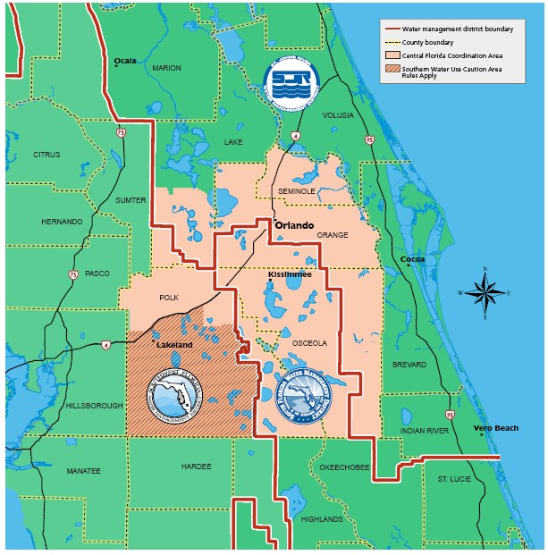

**Figure 1. Boundaries of the Central Florida Water Initiative (CFWI) study area showing overlapping jurisdictions of the three Water Management Districts**

5 November, 2013

The most prominent natural features are ancient sand ridges, lakes, rivers, and wetlands. Physiographic features range from the west‐central area dominated by low ridges, to a flat landscape in the eastern and most western sections (Lake and Polk Counties) (**Figure 2**). The Lake Wales Ridge is the largest ridge feature in the CFWI and has the highest land elevations in peninsular Florida. The ridges have numerous sand‐bottomed lakes, sinkhole lakes, and seepage wetlands that form along ridge slopes. The Osceola Plain is the dominant flat landscape within the CFWI study area boundary. Elevations range typically from 50 ‐70 ft. above mean sea level (MSL). Numerous lakes and wetlands occur on the Osceola Plain, many of which have organic soils. Further discussion of the features of lakes within these areas can be found in Schiffer (1998).

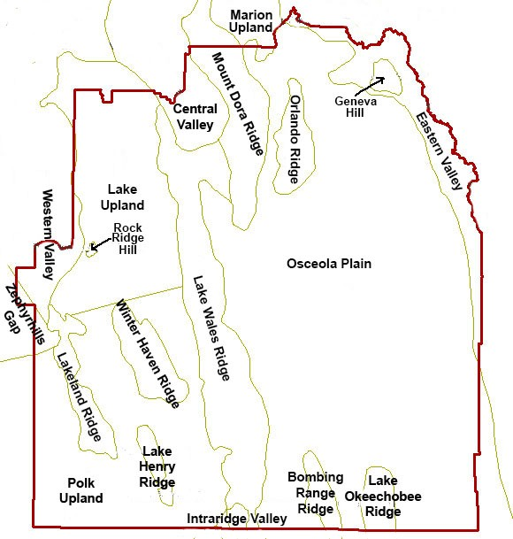

**Figure 2. Generalized boundaries of the major physiographic provinces (based on Brooks, 1982) within the CFWI study area boundary.**

**Land use/land cover**

Land use and land cover types in the CFWI study area have changed over the past decade (**Figure 3**). Wetlands and water bodies are the most extensive land cover types and represent about 32% of the project area. Agriculture (26‐28%) and urban lands (13‐17%) make up other significant land areas. Major land cover changes between 1995 and 2009 were a 4% increase in urban lands and a corresponding

November, 2013 6

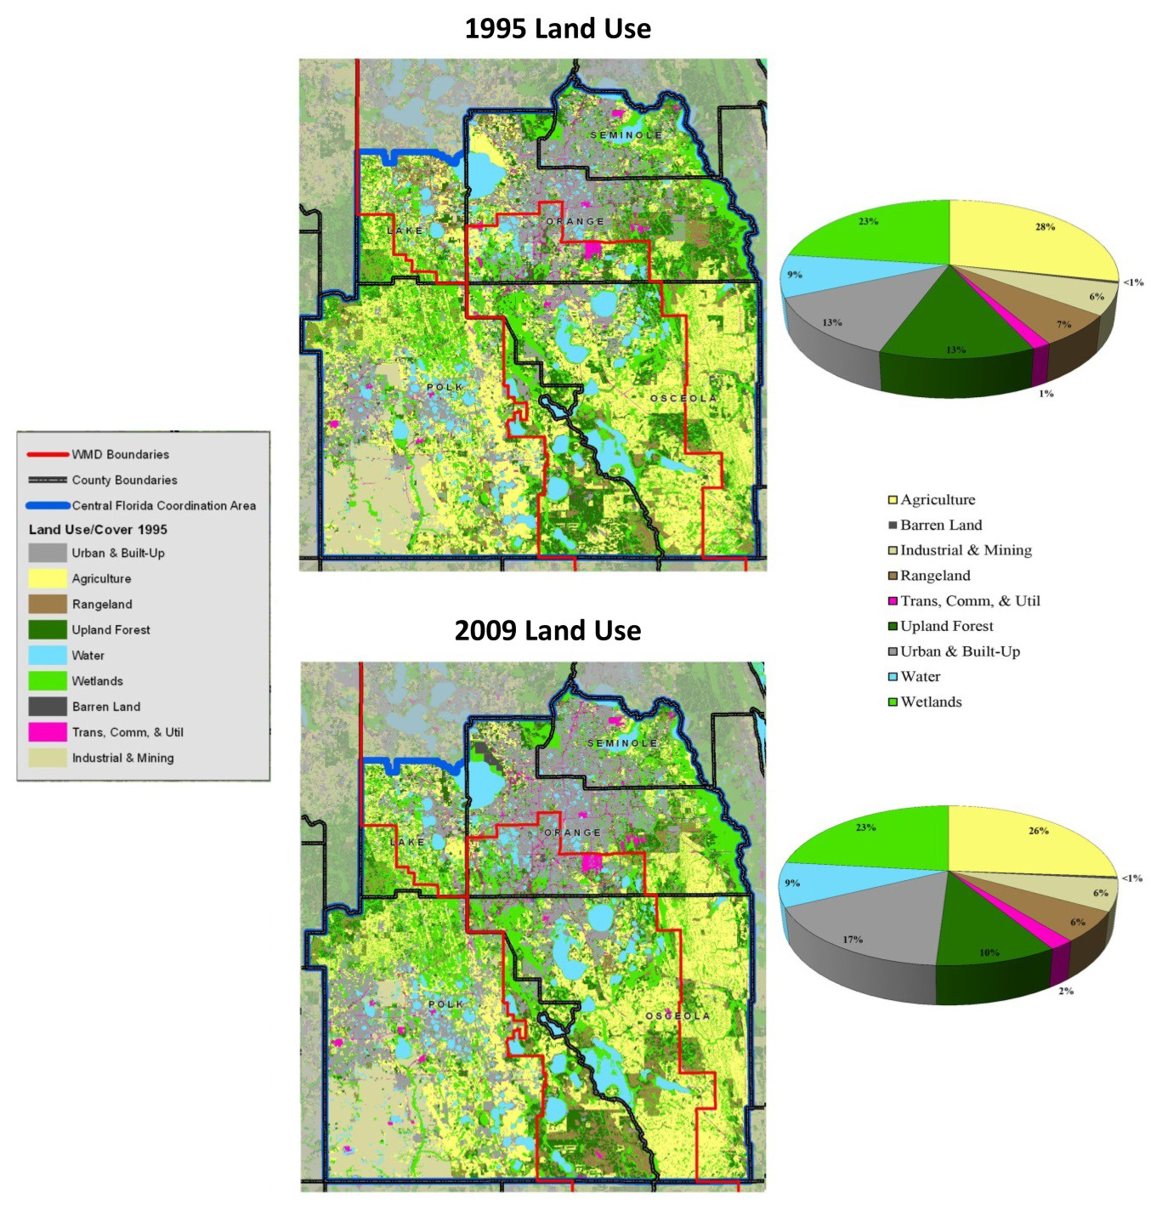

**Figure 3. Land use in the CFWI study area, based on the Florida Land Use Cover Classification System (FDOT, 1999), indicating changes in major land use types that occurred between 1995 and 2009. Source: USGS data compiled for the CFWI Hydrologic Analysis Team Wetlands.**

decrease (3%) in agricultural and upland forested lands. Each percentage point of change represented an area of about 33,734 acres (13,652 hectares).

The main urban feature in the CFWI is the Orlando metropolitan area, which has a population of approximately 2.1 million full‐time residents and hosts some 51 million tourists annually (Visit Orlando Research and Statistics, 2013). Significant urban development also exists along the Interstate 4 highway corridor between Orlando and Tampa. Other man‐made landscape alterations include large phosphate mines and extensive mine reclamation areas located within the SWFWMD jurisdictional boundary in southwestern Polk County and large‐scale agriculture (mostly citrus) on the Lake Wales Ridge. Wetlands

7 November, 2013

comprise approximately 23% of the study area (**Figure 3**). Various types of wetland systems occur within the region, ranging from small isolated marshlands and isolated ponds to large interconnected strand forests and river floodplains. Thousands of wetlands of various types were identified within the region based on examination of satellite imagery and aerial photography.

**Soils**

Soils within the CFWI range from excessively drained to very poorly drained along a gradient from very dry (xeric) to wet (hydric) habitats. Soils are classified based on distinct characteristics, which at a local level are largely the result of differences in water levels. Soil orders, the highest level of soil classification, can generally be mapped with respect to physiographic regions, where Spodosols dominate the plains, Entisols dominate the ridges and extremely wet areas, Histosols dominate the discharge areas, and Ultisols dominate the areas of the panhandle and northern peninsula where more clay was present in the parent soil material (**Figure 4**).

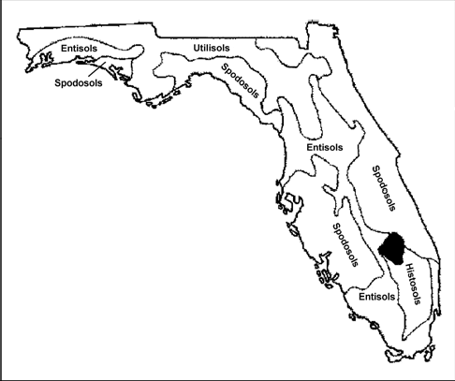

**Figure 4. Generalized distribution of soil orders in Florida (from Collins, 1985).**

The eastern and western regions within the CFWI boundary are dominated by plain and ridge physiography, respectively. Dominant soil orders are thus Spodosols (plain) and Entisols (ridge). Spodosols have a characteristic dark, organic rich subsurface layer with or without aluminum or iron and Entisols have very little soil development within the upper 6 ft. (2 meters) (classification depth).

In either physiographic region (plain or ridge) as the habitat transitions from uplands to wetlands, soils develop certain characteristics that are linked to water levels. These characteristics are generally associated with the accumulation, depletion, or translocation of organic matter or iron and when certain criteria are met, can be used to identify hydric soils (NRCS 2010). Hydric soils are soils that formed under conditions of saturation, flooding, or ponding long enough during the growing season to develop anaerobic conditions in the upper part.

**Surface water and groundwater**

Surface water levels and flows depend on inflow from areas adjacent to the study area, rainfall within the basin, storage, and outflow to other basins. Several primary surface water features provide

November, 2013 8

drainage for the Central Florida area, including the upper St. Johns, Ocklawaha, Withlacoochee, Hillsborough, Alafia, Peace, and Kissimmee rivers (**Figure 5)**.

In most of these watersheds, rainfall within the basin is retained in lakes and wetlands and eventually moves slowly downstream by seepage, surface runoff, and stream flow. Lakes in the Kissimmee Chain, which are the primary surface waters in northern Osceola County, eventually connect to the Kissimmee River that flows south out of the study area into Lake Okeechobee. Most lakes in the rest of the study area are isolated from one another, drain internally and exchange water primarily with the atmosphere and by providing recharge for the underlying aquifer systems.

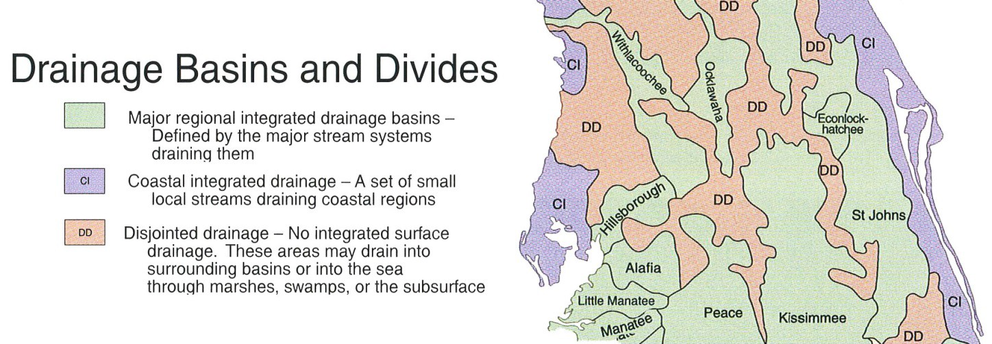

**Figure 5. Surface water basins of the upper St. Johns, Oklawaha, Withlacoochee, Hillsborough, Alafia, Peace, and Kissimmee rivers in Central Florida. Source: Fernald and Purdom (1998).**

Three major hydrogeologic units underlie the study area: the surficial aquifer system (SAS), the intermediate confining unit (ICU), and the Floridan aquifer system (FAS). The surficial aquifer is primarily recharged by rainfall, and interacts with surface water features, such as wetlands, lakes, rivers, and canals. The surficial aquifer also provides temporary storage for infiltrating water that eventually percolates down through the intermediate confining unit to the underlying Florida Aquifer System, or moves laterally to discharge areas.

***Water budget and its relationship to groundwater***

Water levels in lakes and wetlands in the CFWI are the result of a balance between water flowing into the system and water flowing out (**Figure 6)**. Inflows include rainfall, surface water runoff, streams and rivers and groundwater seepage. Outflows include evaporation, surface outflows to streams and rivers and seepage out of the system. During the wet periods, there is a net surplus of inflows relative to outflows and water levels increase. During dry periods, the balance is reversed and water levels decline.

Water levels in lakes and wetlands generally reflect water levels in adjacent shallow groundwater (**Figure 7**). The shallow groundwater may be connected directly to deeper groundwater aquifers, such that withdrawals from the deeper aquifer result in a lowering of groundwater levels and thus a reduction in water levels in the lake or wetland. On the other hand, if there is an impervious layer beneath the surface, the water table in the shallow groundwater and surface water in the lake or wetland may fluctuate independently from deeper groundwater levels.

9 November, 2013

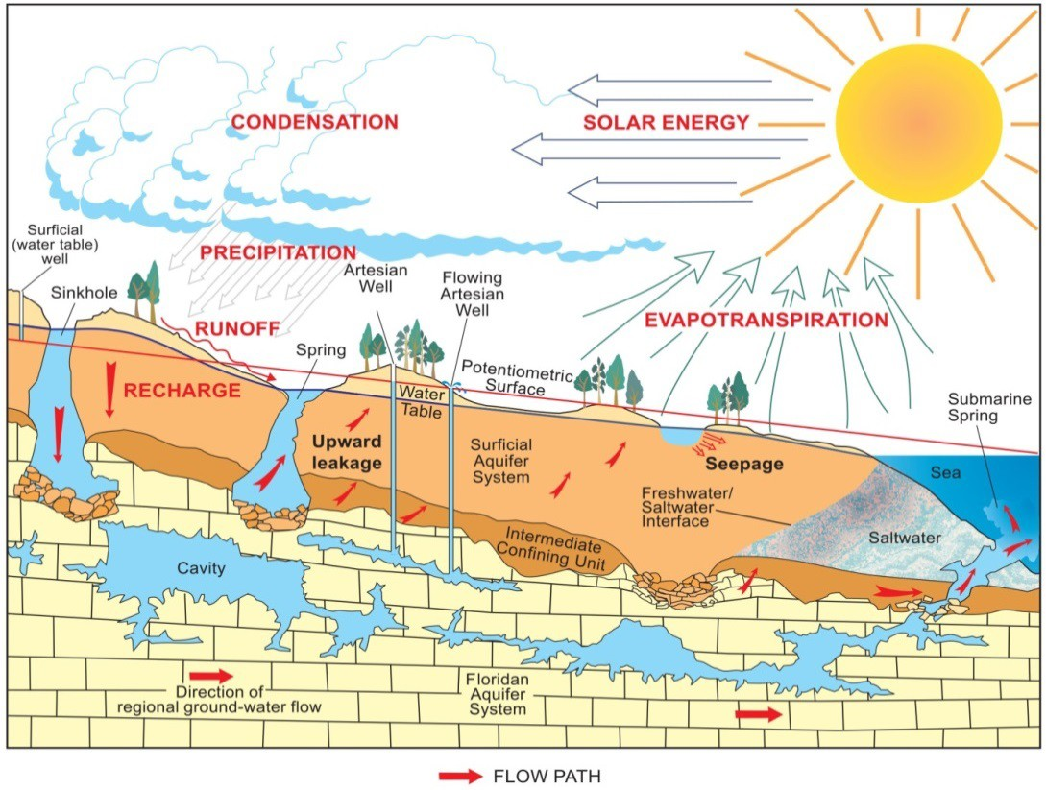

**Figure 6. Cross‐section of Central Florida showing water budget components (from Schiffer, 1998; Fernald and Patton, 1984).**

***Ecological responses to water level variations***

The species composition of a wetland may change over time as a result of natural climatic fluctuations or human activities. A change in hydrologic conditions in the wetland will result in a change to wetland plant communities. A net increase in the amount of water flowing into the system may alter the upland‐ wetland margin and the zonation of wetland plant species along the hydrological gradient. Likewise reduced inflows or water withdrawals may result in overall decline of water levels, a decrease in the total area of the wetland, and a transition from hydrophytic to upland vegetation along the margins (**Figure 8**). Changes in water levels and vegetation may also alter soil characteristics.

November, 2013 10

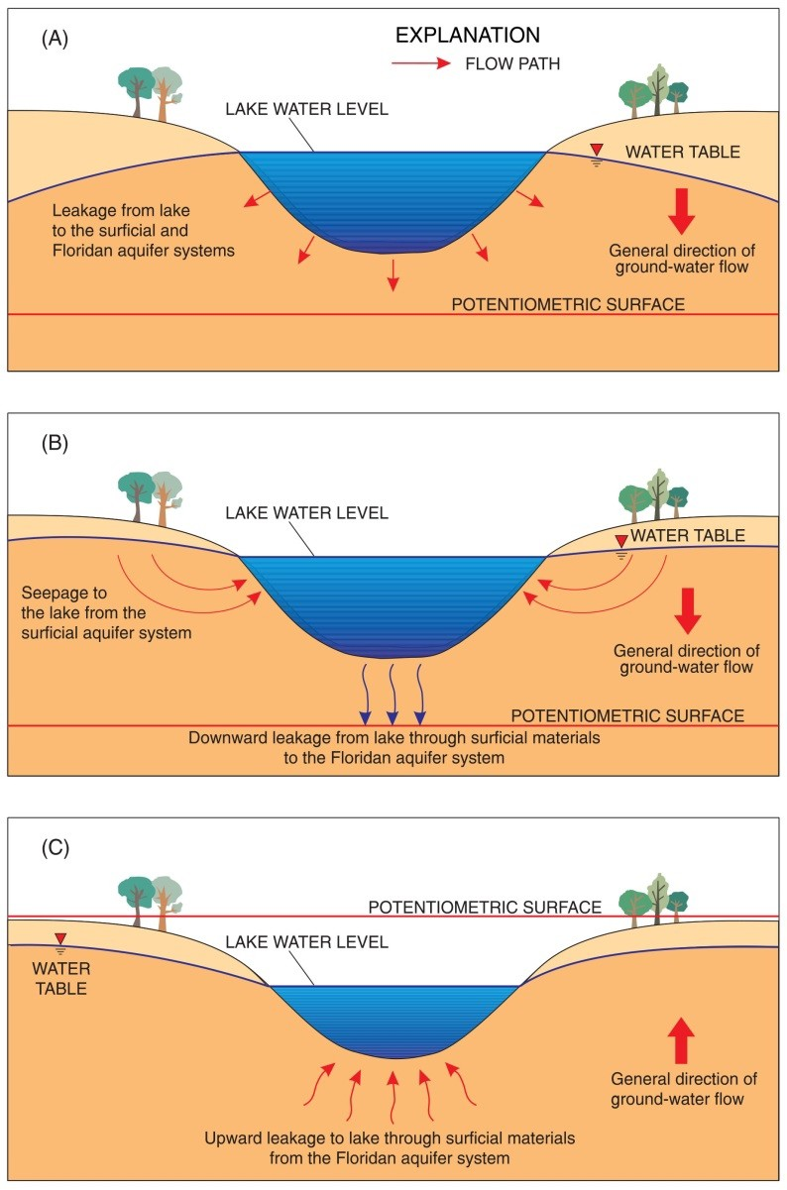

**Figure 7. Lake water exchange with groundwater. (a) When the water level in the lake is higher than the water level in the surrounding shallow aquifer, the lake acts as a source of water to the aquifer. (b) If the lake is connected to an underlying artesian aquifer and the lake level is below the water table, water flows from the shallow aquifer into the lake and flow continues into the deeper aquifer. (c) If the lake is connected to an underlying artesian aquifer, and the water level in the lake is lower than the potentiometric surface of the deeper aquifer, water flows from the deeper aquifer into the lake (from Schiffer, 1998).**

11 November, 2013

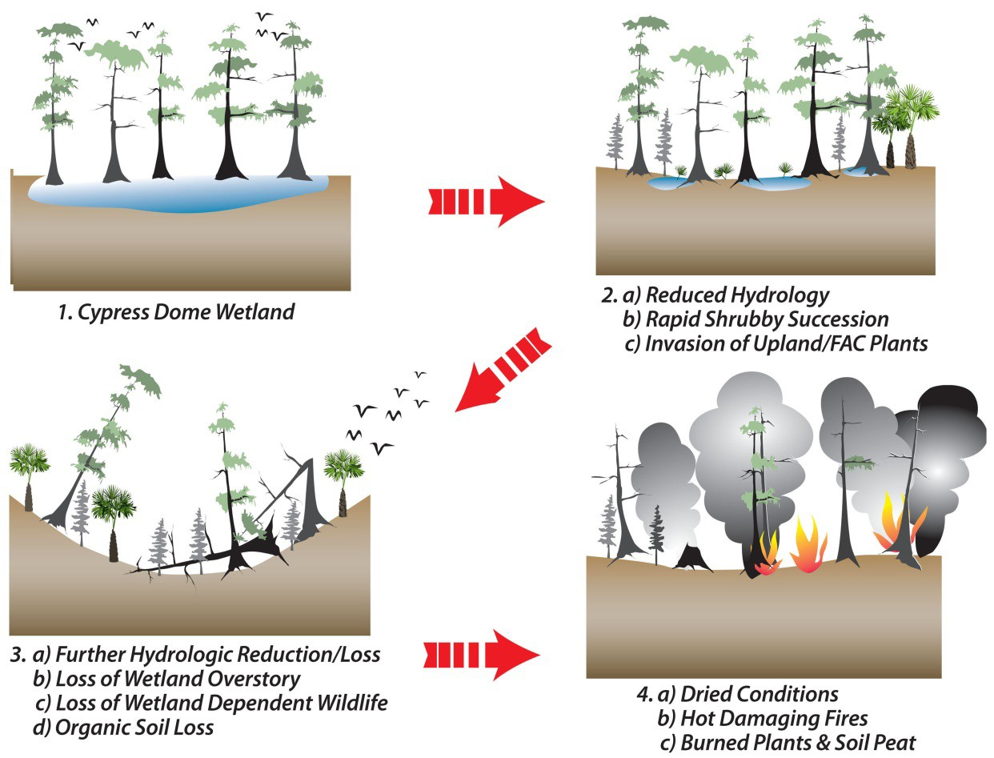

**Figure 8. Major wetland changes in water‐table drawdown areas. Prepared by Pati Twardosky and Kenna Harrison, SWFWMD**

## Use of Indicators

Scientists can observe or measure a number of wetland features to determine recent hydrologic conditions and whether changes are occurring or have occurred in the past. Some of these indicators of reduced water levels include: 1) the invasion of upland species; 2) the presence of dead or dying plants due to prolonged dehydration; 3) changes in plant species composition over time, especially along transition zones between wetter and drier plant communities; 4) leaning or falling trees due to soil oxidation, desiccation or compaction; and 5) the presence of upland woody plants in areas typically dominated by wetland species. The presence of any one or a combination of these wetland impacts can be used to infer altered wetland water levels and identify wetlands that have been stressed by reduced water levels. Hydrologic records can also be used in combination with surveys of water levels and plant zonation to develop surface water inundation and dewatering signatures (SWIDS) that define the hydrologic requirements of different riparian plant communities. Scientists from the SJRWMD developed a quantitative method for determining SWIDS based on elevations measured along the hydrologic gradient from open water to upland edge and analysis of annual maximum and minimum series stage frequencies (Neubauer et al., 2008). Magnitude, duration, and return interval components of the hydrologic analysis were used to define SWIDS for the minimum, mean, and maximum plant community elevations.

November, 2013 12

# Data Collection and Development of Analytical Tools

## Overview

The EMT was tasked with determining the current status of wetlands and developing tools to analyze modeled future wetland conditions within the CFWI study area. This effort included field studies and landscape level analyses. Wetland field assessments were conducted to characterize vegetation, soils, and hydrologic conditions and look for hydrologic stress indicators. Scientists from the water management districts examined all available data to determine if assessed wetlands had obvious signs of hydrologic alteration and if the wetland was stressed due to chronically low water levels. A subset of wetlands had water level monitoring data that were used to characterize differences in hydrologic characteristics of stressed and unstressed wetlands. These differences were used as the basis of a calculation of the probability that stress would occur to certain wetland types located within the CFWI study area. Details concerning these analyses, methods and tools are provided below and in attachments supplied at the end of this document.

A conceptual representation of the process used by the EMT is shown in **Figure 9**. Details of many of these activities are described in attachments to this document, as noted in the figure. In the first step to characterize the current condition of wetlands, data were collected and compiled from field studies and existing databases. These data were then organized and compiled in geospatial databases to facilitate storage, distribution and analysis. A scientific literature review was conducted to examine methods and analyses used in other similar studies and to provide support for the wetland ecological assumptions and rationales used in this effort.

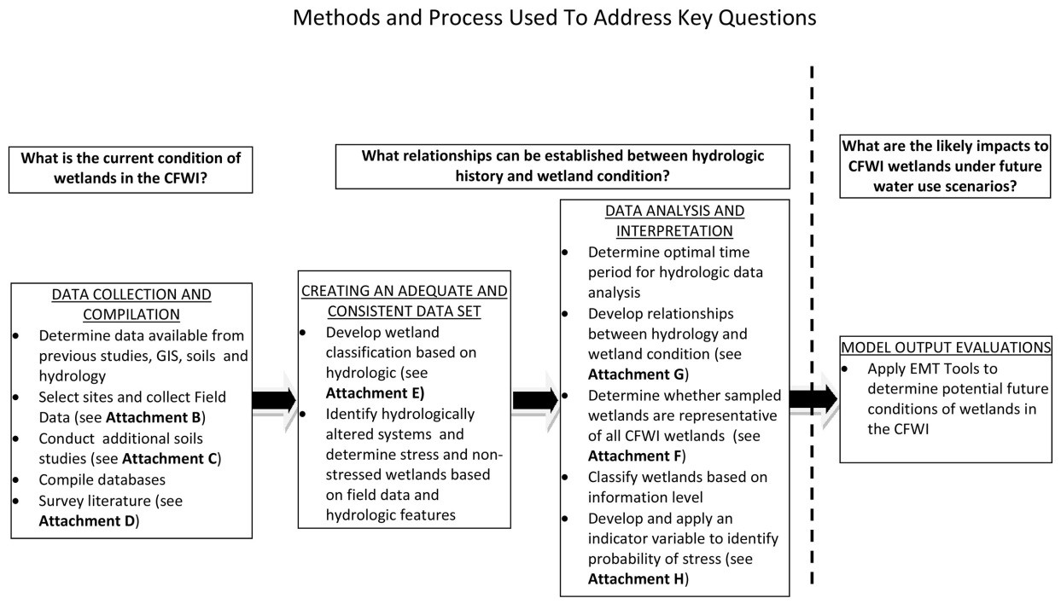

**Figure 9. Process and methods used by the Environmental Measures Team to address key questions identified by the Central Florida Water Initiative.**

In the second step, data were further analyzed and refined to create a set of information that was considered to be sufficiently consistent, complete and adequate to move forward with additional

13 November, 2013

analyses. A new wetland classification system was developed and field and other data were further examined to identify wetland sites that were stressed or hydrologically altered.

In the third step, additional analyses were conducted to determine whether a) there were significant differences in rainfall records between sites that might affect the hydrologic analyses, b) that valid relationships could be established between wetland water levels and stress indicators, and c) whether the wetlands used in this study were representative of the overall wetland population in the region.

Wetlands were classified based on the amount of information available and a hydrologic indicator variable was defined that could be used to define the risk of stress occurring under future conditions predicted by modeling.

## Data Collection and Compilation

The SFWMD conducted a pilot study of wetland assessments within the central Florida study area between August 2007 and March 2008. Following this pilot study, adjustments were made to the methodology based on lessons learned. Additional wetland assessments began in October 2008, incorporating methods used in the SFWMD pilot study (see **Attachment B**) and then continued through an iterative process of site identification, data collection, evaluation and examination of data sufficiency. In the fall of 2010, as part of the newly‐initiated CFWI effort, the EMT compiled results from previous wetland studies and evaluated the data and its spatial and ecological characteristics to determine their suitability. The EMT conducted additional wetland assessments through 2011 and 2012.

**Site selection and field data collection**

During the SFWMD pilot study, approximately 115 wetlands were assessed in central Florida. A variety of wetland types within urban, suburban and rural areas and in different physiographic regions were included. After examining the spatial extent of pilot project study sites, approximately 500 additional sites were identified where wetland assessments could be conducted. Field assessments were conducted by staff from the three water management districts and contractors. All contractors were provided with a Statement of Work that contained descriptions of the methodology and supporting information. To promote consistency in assessments, water management district staff held a one day field training workshop for attending contractors and district staff. Attendees were given demonstrations of the wetland assessment method, instructions for completing the Wetland Assessment Field Form and for photographic documentation. Documents describing the Statement of Work, Assessment Form entries, land use codes and a list of protected wildlife species were given to staff and contractors (**Attachment B**). A subset of the SFWMD pilot project sites was revisited to collect additional data not gathered during the initial assessment.

Of the more than 600 palustrine and lacustrine wetland sites that were identified for study, field assessments were completed on 357 sites (**Figure 10**). Reasons that all of the approximately 600 initial sites were not assessed included: 1) physical access was not feasible or practical, 2) access was denied by the landowner, 3) the historic wetland was no longer present at the site, and 4) the wetland was extremely disturbed and could not be appropriately assessed. In addition, some of the wetlands that were field assessed were not used in the CFWI analyses. These wetlands were excluded for one or more of the following reasons: 1) wetlands were physically altered to an extent that their hydrologic

November, 2013 14

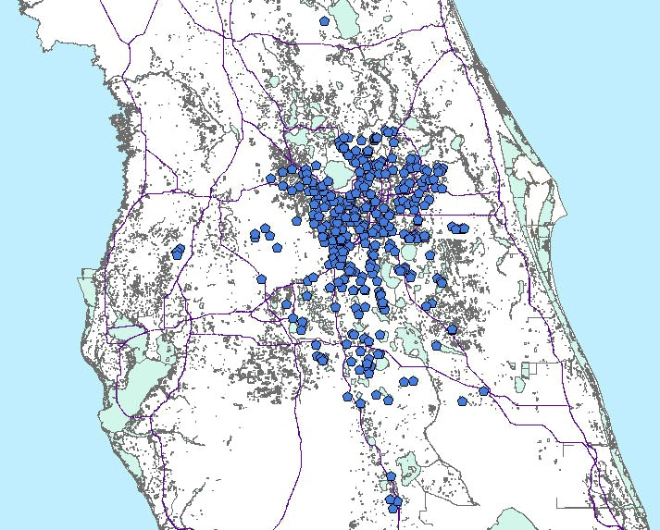

**Figure 10. Locations of wetlands where field assessments were conducted.**

characteristics were likely to have been affected, 2) vegetation communities were highly impacted by plant management activities such as herbicides, mowing, etc. 3) regulation schedules on water bodies caused hydrologic change, or 4) significant basin alterations were present.

A preliminary list of sites for the quantitative analysis of wetland water levels was developed in August‐ September 2011 with the collective input of the EMT, with a goal of identifying water bodies with consistent, long‐term records of hydrologic (e.g., piezometer, staff gage) data. Availability of ecological data was also considered in development of the list. The study sites were distributed throughout the boundaries of the three water management districts, with several outside the CFWI. More than 60 potential evaluation sites were identified based upon availability of historic water level data, location, and ecological condition of the site. Of this total, 44 wetlands had data of sufficient duration, frequency and quality to be included in the analysis. Most of the wetland evaluation sites had been previously assessed by water management district scientists, but not all. For sites where no field assessments had been conducted, teams were deployed to collect these additional data. At all water level monitoring sites, an elevation survey of the upper wetland edge elevation was conducted. While there was a desire to include both wetland and lake sites in the analysis, fewer wetlands had hydrologic data records that met the 6‐year minimum selection criterion for hydrologic data (see “Quantitative Data Analyses” section, below, and **Attachment G**). The water level study sites were widely distributed within each of the water management district boundaries, but several sites were located outside the CFWI study area boundary. Data from sites outside the CFWI study area were included if they were from wetlands that

15 November, 2013

were similar in type and physiographic setting as those wetlands within the CFWI that were included in the quantitative data analysis. The addition of these sites enhanced the statistical sample size and power of the analysis.

**Wetland field assessment**

A Wetland Assessment Field form (see **Attachment B**) was developed to ensure uniform data collection throughout the study area. The form was developed based on contributions from each of the three water management districts and was designed to collect information on hydrologic, vegetative and soil field indicators needed to assess wetland water levels and condition. Elements from the Wetland Assessment Procedure (WAP) used by the SWFWMD, the field data sheet from the SFWMD Pilot Study, and information typically collected during wetland assessments within the SJRWMD were included in the form. The site name, location, and access, as well as wetland characteristics, including wetland type, connectivity and topographic relief were documented. Within each community, information on vegetation, soils, water depth, and hydrologic indicators was recorded. To account for factors other than groundwater withdrawals that may influence wetland water levels, the form included notes and descriptions of any observed wetland alterations, drainage alterations and storm water inflows. Lastly, space was provided for additional notes and comments.

***Determination of wetland edge***

The wetland edge represents a water elevation attained with adequate frequency and duration to prevent long‐term encroachment of upland species. This typically corresponds approximately to the “minimum infrequent high” water elevation as defined by SJRWMD (Neubauer et al., 2008). This elevation is generally more distinct and easily defined in plains wetland systems than in ridge wetlands. An edge elevation was a necessity for calculating the cumulative frequency distributions and water level probability analyses that were used in this study to facilitate comparisons among sites that have large differences in absolute elevations.

The historic wetland edge elevation, within a mesic landscape setting representative of the plains wetlands of this study, can be defined based on biological indicators. Biological indicators are morphological changes or adaptations in vegetation that are a response to sustained inundation and that are permanent or long‐lasting. Many of these changes can be measured and become evident at the elevation of the edge of a wetland. These include elevations of the lower limit of epiphytic mosses and liverworts that are intolerant of sustained inundation, the inflection point on the buttresses of pond cypress (*Taxodium ascendens*), and the lower limit of the root crown on fetterbush (*Lyonia lucida*) growing on tree tussocks (e.g., Carr et al., 2006). Other indicators that represent a period of sustained inundation can also be used. The presence of organic soil horizons in a wetland can often be used as a basis to define the wetland edge elevation where other features are not apparent.

However, the historic edge of wetlands that occur in xeric landscape settings, representative of the ridge wetlands included this study, is often more difficult to determine. Ridge systems, unlike the plains wetlands described above, do not always possess a well‐defined edge. A ridge wetland such as a sandhill wetland or lake, usually exhibits widely fluctuating water levels, extreme highs and extreme lows. These systems do not always express an annual hydropattern and many remain completely dry for several years at a time. As a result, the vegetation, including larger trees, is mostly temporary and is often killed

November, 2013 16

off during the extreme high water events (**Figure 11**). When cypress trees, with their many associated indicators available to measure for edge determination elevations as described above, do not occur within the ridge wetlands, then other long‐term indicators must be used to determine the historic edge elevation. To accomplish this task the EMT employed other measures such as interpretation of historic aerial photographs and site visits by biologists and soil scientists.

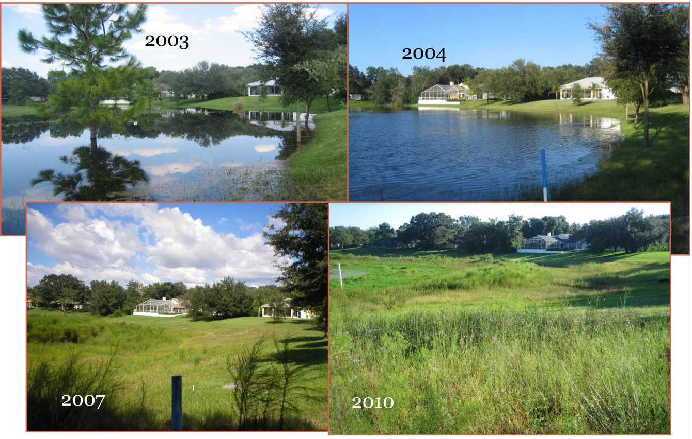

**Figure 11. A sandhill lake in Hernando County Florida exhibiting extreme water level fluctuations resulting in tree and other vegetation death (Greenman, Pedersen Inc., staff photographs, 2010).**

Analysis of historical aerial photography was employed to determine wetland edge changes over time. Encroachment of differing vegetation, the construction of roads or other features through the wetland, size or type changes and changes in hydrologic patterns were reviewed in addition to reviewing the historic edge of a system. If a system has been monitored for any length of time, such as the system in **Figure 11**, vegetation changes and hydrologic extremes are well documented, providing a very good edge determination.

Field visits were made to all 44 sites with hydrologic data. Most ridge sites needed additional visits and more in‐depth analyses by the soil scientists and biologists to determine the historic edge. When present, the elevation of the waterward edge of saw palmettos (*Serenoa repens*) was measured. At least five replicate elevations were surveyed and averaged. Saw palmetto is a very good long‐term indicator of the boundary at the wetland edge because of its very slow establishment and growth rates and requirements for upland conditions for survival. Only distinct and fairly extensive palmetto lines were used, since patches of palmetto can occur on small areas of high ground that are not good indicators of general elevation contours. Other indicators included the highest slope break or scarp in the lacustrine fringe, which represents a high water level that is reached relatively frequently by the lake

17 November, 2013

system. A hydric soil boundary was often used for additional validation of this indicator. Another edge indicator measured was the presence of a line of live oak (*Quercus virginiana*) trees, which represents the long‐term lacustrine fringe. In some cases indicators were not present and soil scientists used numerous features in combination to determine the historic edge boundary. These include distinctive breaks in vegetation and various hydric soils identified by field determinations.

***Photography of assessment sites***

Photographs were taken of each site to provide an overall view of the wetland or lake. Additional photographs were also taken of indicators noted on the field assessment sheet, such as subsidence, fissures, exposed roots, adventitious roots, invasion of upland species, etc.

***Vegetation and zonation***

Determinations were made of how distinct or well‐defined the different vegetation community types and zones (e.g., hydric pine, wet prairie, emergent marsh, deep marsh) were from each other along a hydrologic gradient within a wetland. This included three categories ‐‐ “Well Defined” “Somewhat Defined” and “Poorly‐Defined.” The wetland was further characterized based on the level 3 Florida Land Use Cover and Forms (FDOT 1999) codes to describe the major features of the system. Dominant species (the four most abundant species) in each layer were recorded for groundcover, shrub and canopy strata.

***Habitat condition***

A qualitative description was made of each system’s condition and observed stress factors were listed, including evidence and estimated percentage or number of conditions not attributable to effects of normal seasonal senescence (perennials) or completion of life cycles (annuals). Examples of such stress indicators include the following: 1) dead or dying plants, 2) premature leaf falls, 3) discolored foliage, or

1. dead or stunted plants or impaired growth. Special attention was paid to the following conditions:
   * The presence of upland species invading the wetland fringe or wetland interior.
   * The approximate percentages or numbers of tree falls and species affected as well as obvious of exposure of roots at the base of trees and/or shrubs that were indicative of soil oxidation.

***Soils***

As part of the initial environmental assessment in central Florida, general soil observations were made regarding the presence/absence of organic accumulation at the soil surface. If present, the thickness of the organic layer was documented, if possible, along with any evidence of subsidence. Evidence of subsidence includes, but is not limited to, root exposure adjacent to trees or cracks and fissures in the organic soil layer(s). If observed, these subsidence features were documented by measuring the height of root exposure and the depth of soil fissures with respect to the mean soil surface elevation.

A hydric soils assessment was completed for the 44 wetlands that had hydrologic data. This assessment included interpretations of soil morphologies to help determine the wetland edge, if water levels had been altered, or stress had occurred in the wetland. Soils were described along a transect perpendicular to the wetland or lake system, beginning at the historic edge and terminating within the system. Soils were described at the historic wetland edge and current wetland edge (if different from historic) to document the presence/absence of hydric soil indicators and seasonal high saturation. In addition, soils

November, 2013 18

were observed to the extent necessary to identify the boundary between hydric/non‐hydric soils as well as the landward extent of muck presence, histic epipedon, and histosol. The landward extent of any other hydric soil indicators observed, could be, but was not required to be documented. The location of each soil description was recorded with GPS and the ground elevation was determined. Details regarding the CFWI soils investigations are included in **Attachment C.**

**Figure 12** provides a schematic showing relative locations of the saturation and inundation indicators in and around a wetland, with respect to elevation above and below soil surface.

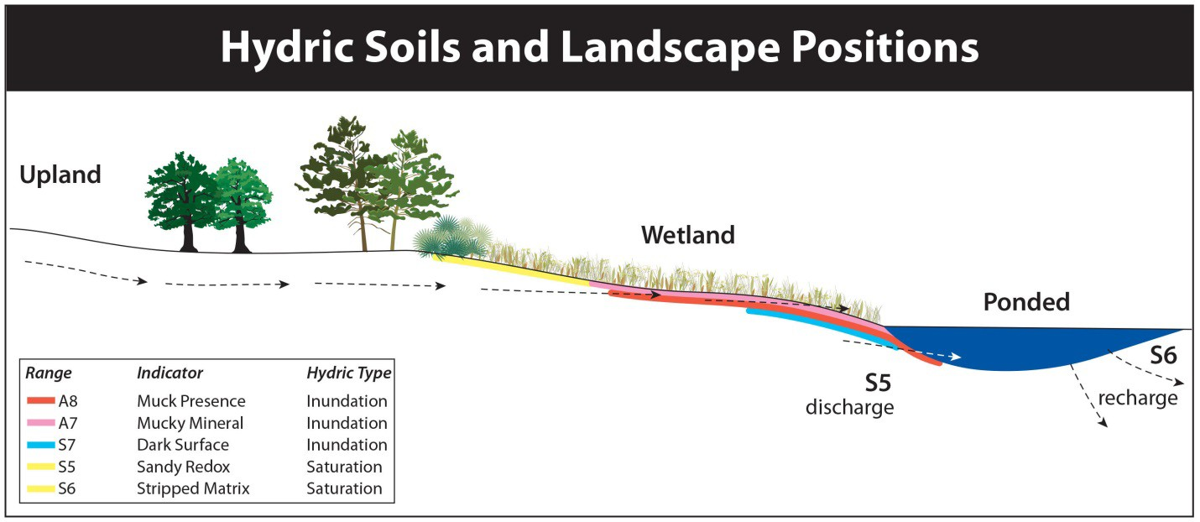

**Figure 12. Cross section schematic of a generalized upland/wetland interface. See Attachment C for further explanation of soil classifications.**

Additional data collection

In addition to the field assessment, the following data were collected for each site:

* + Historical aerials (images obtained from the University of Florida Map and Imagery Library and county databases, DOQQs) and images accessed from Google Earth™ and Bing™
  + Soils (Soil Survey Geographic Database)
  + Topography (U.S. Geological Survey quadrangle and topographic maps)
  + Physiographic Regions (Brooks, 1981)
  + Land use maps (Florida Land Use and Cover Classification)
  + Hydrographic databases (all WMDs)
  + Drainage well maps (SJRWMD)

Based on consideration and evaluation of these data, wetland scientists determined if the wetland was being stressed by chronically low water levels.

***Climate***

Since wetland data collection occurred over several years, knowledge of the recent and antecedent rainfall conditions was important, in order to place observed wetland conditions in their historical context. Available rainfall data were identified by the Data Monitoring and Investigations Team (DMIT)

19 November, 2013

and several long‐term gages were selected. Analysis of these data, including spatial and temporal trends, is described below in the section on “Rainfall analysis.”

***Hydrology***

Historical data were obtained from a number of agencies and other governmental entities to provide the hydrologic data sets for the 44 wetlands that were used in the quantitative assessment. Data sources included the Orlando Utilities Commission, City of Cocoa, Seminole County, Orange County, SFWMD DBHYDRO database, SWFWMD Water Management Information System (WMIS), Water Atlas website, USGS National Water Information System, and the SJRWMD Hydrologic Data Search.

**Database compilation**

A database of field and non‐field data (historical aerials, topography, soils, etc.) was compiled. A naming convention was developed to provide uniform site names that include a district prefix (SF, SJ, or SW) and a unique alphanumeric identifier (e.g., SW‐AA). Some large wetland systems had multiple assessment sites. In these cases, the site names included a number to indicate that multiple assessment sites were located within one continuous wetland system (e.g., SF‐AE1, SW‐AE2, and SF‐AE3). Multiple databases were developed to meet the needs of the study, using formats that are readily available for public access.

***Shapefile database***

A shapefile is a file format type that is used in GIS for geospatial analysis and visualization. A typical GIS map combines data from several electronic files that identify spatial arrangement, global position, mapping projection, feature characteristics and an attribute table that contains data about objects on the map. A geospatial database consisting of a point shape file was used to represent the individual sites and the associated attribute table was populated with data from the field assessments and other sources. The data fields included were those considered to be most relevant to GIS analysis. This shapefile database is available at [www.cfwiwater.com](http://www.cfwiwater.com/)

***KML/KMZ database***

KML is a computer language that is used to express geographic annotation and visualization in Google Earth™ and KMZ is the compressed data form of a KML file. This database can be accessed from any location via the internet using software available for free to individual users or at a cost to institutions. It is also highly flexible with regard to the types of data that can be displayed and can be made extremely user‐friendly by allowing point‐and‐click access from an interactive map. The CFWI KML/KMZ database, however, is not suitable for numerical or statistical analyses.

All hard‐copy data (i.e. paper documents) were scanned into electronic files and combined with field photographs, historical aerial imagery time series and data tables from the shape file to create a comprehensive collection of all data from each assessment site. Using KML, wetland assessment sites were displayed through the Google Earth™ application as map points. When a point on the map is accessed, the associated data are displayed in a pop‐up window. This KML/KMZ database is available at [www.cfwiwater.com.](http://www.cfwiwater.com/)

November, 2013 20

## Creating an Adequate and Consistent Data Set

***Wetland classification by physiographic setting and GIS methods***

To help develop relationships among physiographic setting, water levels and wetland condition, each of the 44 wetlands used in the statistical analysis of stress was classified on the basis of its immediate physiographic setting. This classification was based on a combination of physiographic provinces as defined by White (1970) and Brooks (1982), and findings from an extensive study by Schmutz and Willis (2004), demonstrating differences in wetland hydrologic response related to xeric (ridge) and mesic (plains) landscape settings. Because physiographic provinces relate to large land areas in which there is considerable variation, the classification was further refined to consider the specific setting of each wetland. Topography and soils in the immediate vicinity, and their associations with physiographic setting were evaluated. For example, a wetland in a ridge physiographic province but located on a lake plain with only minor relief and Myakka soils (associated strongly with flatwoods), would be classified as a plains wetland.

The full classification of wetlands based on size, physiography and primary water source was developed using GIS. All wetlands were identified as being located in either plains or ridges provinces based on the criteria defined above. Wetlands and lakes were further classified within isolated, seepage, and various types of flow‐through categories. This classification was used in conjunction with the hydrologic models to estimate spatial patterns of likely change in the region. Details of the classification and a summary of the GIS analyses are provided in **Attachment E**.

***Hydrologic alterations***

A wetland was classified as *hydrologically altered* if there were known manmade or natural modifications within the system or its watershed that resulted in surface water hydrologic changes. Modifications were determined based on a review of historic aerial photography, site visits and information from the drainage well database. Examples of features that could result in this designation included the following:

* + Presence of sink holes resulting in discharge of surface water to a deeper aquifer
  + Construction of holes or channels (through confinement) next to or within a wetland or lake
  + Development within or through a wetland
  + Activities within the watershed that modify the size of a wetland or lake, the amount or timing of surface flows, or connectivity to other wetland and lake areas
  + Water levels managed artificially by control structures or regulation schedules
  + Impoundment or a dike system surrounding the site
  + Presence of drainage wells or Rapid Infiltration Basin Systems (RIBS) within or adjacent to a wetland
  + Surface water drainage features (ditches, structures, berms) in the wetland

The hydrologically altered classification was applied as a screening tool to identify wetlands with obvious features that could cause or contribute to a lowered water table. Other hydrologic alterations that could affect water levels in the system, but which are not considered in this classification, include:

* + Chronically high water levels caused by diversion of water into the system

21 November, 2013

* + Surface water/groundwater withdrawals or inputs
  + Level of development around a system
  + Regional lowering of the groundwater table.

In addition to the stress determination, the EMT concluded that changes in wetland water levels due to groundwater withdrawals are difficult to predict in channelized wetland systems where water levels are partially controlled by surface water inflow and outflow systems that are not represented in detail by the ECFT groundwater model. Hydrologically isolated systems have no surface water discharge component, and are controlled by the balance between inflows from surface water and groundwater versus discharges to ET and groundwater recharge. This combination of water level influences is much better represented in the ECFT model, and is more controlled by (and thus inherently vulnerable to) alteration of groundwater elevations due to groundwater withdrawals. Hydrologically isolated wetland systems are distributed throughout the CFWI area, so the EMT focused on these systems for overall wetland protection; if the hydrologically isolated systems are adequately protected from groundwater impacts, it seems likely that less vulnerable systems would also be protected.

***Hydrologic stress indicators***

Environmental scientists from the three water management districts convened to discuss and review the status of each field assessed wetland for the purpose of making determinations of hydrologic stress.

Early in the wetland assessment process, concerns were raised about separating impacts from normal extreme climatic conditions and human activity. This concern became heightened since some wetland assessments were conducted during a period of drought conditions. Field observations of severe drought impacts and the availability of historic aerial time series (early 1940s to present) allowed the environmental scientists to identify drought impacts in unaltered wetlands and to refine stress indicators. The wetland stress indicators used in the EMT’s stress assessment were as follows:

* + Invasion by plants of drier communities into a wetland. This indicator focused on a permanent change, rather than a temporary condition. An example is the establishment of woody species into a marsh or lake littoral zone, or establishment of upland woody species into an area that was formerly wetlands. To acknowledge the effects of normal periodic droughts, the appearance of transient species, such as upland tree seedlings or herbaceous upland species (e.g., dog fennel, *Eupatorium capillifolium*), was not considered to be a stress indicator, particularly when no other stress indicators were present. Historic aerial photography was also examined for longer‐term trends of drier species invading wetland areas through time.
  + Oxidation and/or loss of organic soil. Soil loss that occurs due to chronically low water levels, resulting in oxidation of organic matter, is usually evidenced by exposed roots on trees or shrubs. Efforts were made to discern if soil losses were due to fire, which is not necessarily associated with hydrologic alteration. In situations where no other indicators of hydrological alteration were present, no other hydrologic stress indicators were present and there was a known history of fire within the wetland, organic soil loss was not considered an indication of hydrological stress. Soil erosion can occur in flowing systems or along lake shores and soil losses in these situations were not considered to be indicators of wetland stress due to reduced water levels.

November, 2013 22

* + Subsidence. A depression may form within the wetland or lake due to soil compression or collapse of surface rock overlying an underground sinkhole. Sinkholes may form by natural processes of erosion or may be induced by nearby groundwater withdrawals. The wetland may display stress features even if the collapse has not created a direct connection to the underground aquifer. If the sinkhole provides a direct connection to the underlying aquifer that drains the surface water, then the system was described as hydrologically altered.
  + Presence of soil fissures. Soil fissuring occurs in non‐forested wetland organic soils and results from a very low water table. Under these conditions, organic soil dries, desiccates and may form deep, gaping cracks. Within the normal range of hydrologic conditions in a wetland, soil fissuring does not occur. Under exceptionally severe and prolonged drought conditions, superficial (shallow) fissuring may occur only near the soil surface. Deep soil fissuring was considered to be an indicator of hydrologic stress.
  + Abnormally high numbers of leaning or falling trees. Soil loss due to oxidation or compaction, caused by reduced water levels, may lead to abnormally high numbers of tree falls within forested wetlands. Normal wetland tree fall or tree fall caused by fire or storms was not considered an indicator of hydrologic stress. To determine whether the number of tree falls within a particular wetland is more than would normally be expected, the patterns of tree fall across adjacent areas were examined on aerial photography to look for localized effects and severity of tree fall. Localized tree falls may indicate the presence of a contributing factor other than tropical cyclone impacts.
  + Dead or dying vegetation as the result of excessively dry conditions. Normal winter senescence or impacts from freeze events were not considered to be indicators of stress.
  + Changes in plant community composition through time. An example is when wet prairie species become established in an area that was historically marsh or open water. In addition to field assessment information, historic aerial photography was examined for evidence of plant community change through time. A “yes” or “no” field was included in the database to reflect a determination of whether the plant community had changed over time.
  + Multiple age cohorts within a forested wetland. Occasional saplings and a range of age classes in a forested wetland are normal and occur in healthy wetlands. The presence of large numbers of young trees in an otherwise mature wetland forest, when found in an area that was formerly too wet for trees, can indicate a reduced water table. The occurrence of large numbers of young trees in areas where tree fall occurred due to storms was not considered to be a stress indicator.
  + Evidence of permanently reduced wetland water levels. Signs of a historic wetter hydrologic condition could include: 1) buttressing with inflection points high on old cypress trunks found further landward within the wetland, or no buttressing on pond cypress, *Taxodium ascendens*; 2) old wetland trees persisting in landward areas where there is little or no standing water; 3) a relic upland/wetland transition zone, such as a live oak line, where there is no evidence of recent water level changes enforcing the transition; 4) a historically logged wetland with old logged tree stumps buttressed higher than the buttresses on current trees; 5) cypress trees downed by root rot; and 6) historic aerial photography that shows evidence of reduced wetland water levels. If the extent of a wetland or lake appeared to decrease through time, this was considered to be evidence of reduced water levels.
  + Absence of hydrologic indicators. If no hydrologic indicators were observed in a wetland where indicators should be observed (such as a swamp), the wetland was considered to be

23 November, 2013

stressed. Examples of hydrologic indicators include lichen lines on buttressed trees that extend below the buttress to the ground and water stain lines at appropriate elevations on trees or dock pilings.

***Hydrologic stress definition and determinations***

Wetlands were identified as being stressed if they were observed to have any one of the following characteristics:

* + A multi‐decadal trend of decreasing water levels seen on historic aerial photography. Trends were: a downslope migration of upland vegetation, a decrease in the aerial extent of the wetland, a shift from emergent vegetation (obligate wetland species) to long‐lived woody vegetation (facultative species), diffusion of the transitional zone between upland and wetland plant communities, and the establishment of upland trees in historic wetland area.
  + Absence of hydrologic indicators observed during field assessments in wetlands where hydrologic indicators could be present (e.g. lichen lines that extend to the soil surface).
  + Evidence of permanently reduced wetland water levels or invasion/establishment of species from drier communities.
  + Soil oxidation or loss (due to reduced water levels) observed during the field assessment in wetlands that had organic soils. In forested systems, this was typically linked with an excessive number of leaning or falling trees.

The remaining indicators were used as supporting information where hydrologic stress was determined by the above characteristics.

The term “stress” as defined by the EMT should not be confused with ecological “stressors.” For example, periodic extreme hydrologic conditions driven by climate (drought and flooding events) are stressors that act to shape the ecological characteristics of wetlands. These events, including occasional extreme droughts, are essential to the overall health of wetlands. Transient stress resulting from extreme or prolonged drought can lead to the invasion of upland vegetation into wetlands (particularly herbaceous species such as dog fennel) and the establishment of a new age class of tree seedlings and saplings. Extreme drought also limits the upslope extent of hydric organic soils by oxidation and compaction processes. Nevertheless, these changes are largely reversible over several years and are considered as a natural aspect of wetland ecology. In fact, periodic extreme droughts are necessary for many important wetland trees and shrubs, allowing periodic recruitment of seedlings into the population. In addition, periodic extreme flooding events, such as those associated with tropical cyclone events, eliminate upland vegetation from the wetland footprint. All wetlands undergo these subtle shifts in vegetation with climatic variability.

The EMT’s stress indicators described above were refined to exclude the effects of periodic drought and were focused on wetland hydrologic stress that was associated with non‐natural (outside of normal climatic variability), generally human‐induced, chronically reduced water levels that persisted for many years.

Although climatologists are now documenting longer‐term cycles of rainfall patterns, such as the Atlantic Multi‐decadal Oscillation, these effects have occurred throughout history, and extend across the entire region, rather than within individual wetlands. In addition, the review of historic aerial photographic time series (early 1940s to present) would reveal whether landscape‐level water level

November, 2013 24

fluctuations have occurred in association with changes in regional rainfall patterns. Because the stress assessment considered field indicators that were focused on abnormally dry conditions and included a multi‐decadal review of historic aerial photos, these multidecadal cycles are not considered to have affected the determination of stress for individual wetlands in this study.

The definition of stress used in this analysis was conservative and only identified wetlands where substantial long‐term ecological change due to reduced water levels had already occurred. When stress indicators were present, a wetland was flagged as potentially stressed. Potentially stressed wetlands were further examined to determine if the observed indicator was related to reduced water levels or another factor. For example, many hydrologic indicators were generally not present in herbaceous wetlands. Some wetlands may be stressed by permanently altered water levels that occurred in the recent past, but have not yet developed long term stress indicators to the degree that could be reliably discerned. It is recognized that, because of a lag time between hydrologic alteration and expression of long‐term indicators of stress, some wetlands that were observed to not be stressed may be found later to have stress indicators.

## Data Analysis and Interpretation

Rainfall and other hydrologic data for the study area were analyzed to define an optimal time period that would correspond to the time period used by the modeling effort and best represent available rainfall and hydrologic data for the study area.

**Rainfall**

Because rainfall varies temporally and spatially in Florida, hydrologic data with different Periods‐of‐ Record (POR) and timeframes can have different characteristics. When comparing data among assessment sites, the potential influence of different data collection periods may be significant. To address this issue, the degree of correspondence between the PORs of the sites and measured data at the rainfall gages was evaluated. The average departure from normal was determined for the long‐term rainfall gauge nearest to each site for a period of time corresponding to the data record. Central Florida rainfall data spanning from approximately 1991 through 2011 were compiled (**Table 1**) and used in this analysis. The 90th percentile and 10th percentile statistics were used to characterize the upper and lower

**Table 1. Monitoring stations used in the EMT rainfall analyses.**

|  |  |  |  |  |  |
| --- | --- | --- | --- | --- | --- |
| **Site ID** | **Site Name** | **Longitude** | **Latitude** | **Site Type WMD Data Source** | |
| **1641** | Clermont R | ‐81.723000 | 28.455000 | RF | St Johns River |
| **25147** | Mountain Lakes NWS | ‐81.599236 | 27.938631 | RF | Southwest Florida |
| **6628** | Orlando | ‐81.333300 | 28.433300 | RF | St Johns River |
| **17350** | ROMP 88 Rock Ridge | ‐81.906739 | 28.309450 | RF | Southwest Florida |
| **7892** | Sanford | ‐81.268600 | 28.816700 | RF | St Johns River |

ranges of the rainfall data. The data were also examined for extreme rainfall events, such as those associated with the passage of tropical cyclones, and long‐term droughts. The 90th percentile and 10th percentile statistics were used to characterize the upper and lower ranges of the rainfall data. The data were also examined for extreme rainfall events, such as those associated with the passage of tropical cyclones, and long‐term droughts.

25 November, 2013

**Hydrologic Characteristics of Wetlands**

The objective of this data analysis is to examine relationships between hydrologic data and wetland stress condition, so that these relationships could be used to evaluate outputs from hydrologic model simulations. Wetland hydrologic monitoring data were analyzed to identify a single representative indicator value that showed a consistent relationship to the presence or absence of stress.

Topographic or elevation gradients in wetland and aquatic (lacustrine and palustrine) systems can be simple, with a single community type, or more complex, involving transitions from uplands to swamps, marshes, submerged aquatic plants and finally to open water (**Figure 13a**). The schematic also identifies the elevation where the “wetland edge” can be defined.

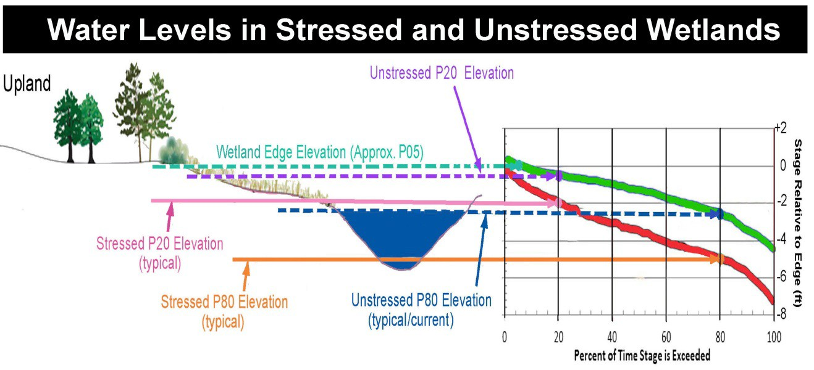

**Figure 13. a. (Left) Profile of a typical wetland showing transition of plant communities from uplands to open water as they relate to land elevation and water level regime. b. (Right) Hypothetical frequency distribution curve for water levels in an unstressed wetland (green) and a stressed wetland (red). showing the percentage of time (x axis) that a particular water level stage(y‐axis) is exceeded.**

Cumulative frequency distribution (CFD) plots of hydrologic data from the wetlands (**Figure 13b**) provide a means to further analyze and compare hydroperiod characteristics among sites. The vertical axis represents the water level in the wetland and the horizontal axis shows the percentage of time that a measured stage was equaled or exceeded. As a convenience, the probabilities are indicated by the letter “P” placed before the numerical value of the percentage. For example, if a given water level value is exceeded only 5 percent of the time, it has a corresponding label of P05. Similarly, if a particular water level is exceeded 80 percent of the time, it is labeled as P80. The P50 value corresponds to the median water level value in the data set.

**Figure 14** shows the locations of the Class 1 study sites and stress determinations. **Table 2** shows each site characterized by a unique identification code, water body type, presence of stress and/or hydrologic alteration, physiographic setting, P80, and wetland edge elevation.

November, 2013 26

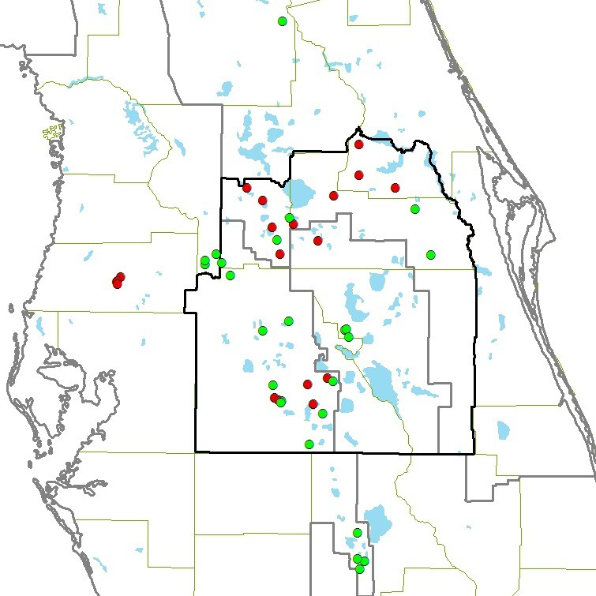

**Figure 14. Class 1 EMT study sites Red=stressed, Green = unstressed sites.**

**Frequency distributions of water levels in CFWI wetlands**

The period from 1991 to 2011 was defined as the target time frame for analysis to meet several objectives: 1) a time period that overlaps most of the CFWI model assessment period (1995‐2008), thereby allowing direct comparisons to simulated aquifer levels calibrated under the same rainfall conditions; 2) a representative duration to include dry (1999‐2001) and the wet (2004‐2005) years; and

1. to allow the use of wetland water elevation data collected more recently through water use permit monitoring.

Within this two‐decade target period, the hydrologic POR for individual sites ranged from six to more than 20 years. Of this period, all 44 sites had relatively complete records only for the six‐year period from 2006‐2011.

27 November, 2013

**Table 2. Site descriptions of the 44 CFWI EMT Class 1 Wetlands. Soils studies were used to determine the edge reference elevation for each site (Attachment C). Hydrologic analyses provided the P80 values (Attachments F and G).**

**Additional studies were conducted by the EMT to determine whether sites were hydrologically stressed (see section entitled “Hydrologic Stress Definition and Determinations”).**

|  |  |  |  |  |  |  |  |  |
| --- | --- | --- | --- | --- | --- | --- | --- | --- |
| **No.** | **Site Name** | **P80 Edge Reference Physio‐ (2006‐2011) Elevation**  **ID Code Region (ft. NGVD 29) (ft. NGVD 29)** | | | | **Hydro**  **θ (ft.) Stressed Altered** | | |
| **1** | Unnamed Cypress | SJ‐LA | Plain | 69.26 | 70.44 | 1.18 | No | No |
| **2** | Green Swamp Marsh #304 | SW‐LI | Plain | 92.64 | 93.90 | 1.26 | No | No |
| **3** | Green Swamp #1, #298 | SW‐LM | Plain | 98.43 | 100.6 | 2.17 | No | No |
| **4** | City of Cocoa, Well 9T | SJ‐LL | Plain | 71.38 | 74.14 | 2.76 | No | No |
| **5** | Walker Ranch ‐ WR9 | SF‐XZ | Plain | 65.57 | 68.34 | 2.77 | No | No |
| **6** | Green Swamp 7 | SW‐AA | Plain | 103.19 | 106.37 | 3.18 | No | No |
| **7** | Walker Ranch ‐ WR6 | SF‐LB | Plain | 61.65 | 64.47 | 3.47 | No | No |
| **8** | Green Swamp #5, #302 | SW‐LK | Plain | 95.28 | 98.80 | 3.52 | No | No |
| **9** | Walker Ranch ‐ WR11 | SF‐LA | Plain | 64.11 | 67.68 | 3.89 | No | No |
| **10** | Green Swamp #6, #303 | SW‐LJ | Plain | 94.07 | 98.10 | 4.03 | No | No |
| **11** | Cypress Creek #199, W17 | SW‐LE | Plain | 63.34 | 64.95 | 1.61 | Yes | No |
| **12** | Tibet Butler ‐ TB2*** | SF‐YK | Plain | 98.72 | 102.63 | 3.91 | Yes | No |
| **13** | Lake Gem | SJ‐AJ | Plain | 48.74 | 53.39 | 4.65 | Yes | Yes |
| **14** | Cypress Creek #221, W33 | SW‐LH | Plain | 65.92 | 70.79 | 4.87 | Yes | No |
| **15** | Boggy Marsh | SJ‐LC | Plain | 113.82 | 118.82 | 5.00 | Yes | No |
| **16** | Island Lake ‐ 2774 | SJ‐LH | Plain | 81.86 | 87.49 | 5.63 | Yes | No |
| **17** | Cypress Creek #190 "E" Marsh | SW‐LF | Plain | 65.09 | 72.03 | 6.94 | Yes | No |
| **18** | Cypress Creek #223 "B" W46 | SW‐LG | Plain | 60.87 | 68.93 | 8.06 | Yes | No |
| **19** | Lake Leonore (Patrick) | SW‐QH | Ridge | 85.08 | 86.23 | 1.15 | No | No |
| **20** | Lake Annie (Highlands) | SW‐QE | Ridge | 109.95 | 111.49 | 1.54 | No | No |
| **21** | Gator Lake | SW‐QD | Ridge | 129.89 | 131.8 | 1.91 | No | No |
| **22** | Lake Apthorpe | SW‐QF | Ridge | 68.93 | 71.28 | 2.35 | No | Yes |
| **23** | Lake Van* | SW‐QK | Ridge | 131.08 | 134.32 | 3.24 | No | No |
| **24** | Lake Streety | SW‐QJ | Ridge | 103.21 | 105.95 | 2.74 | No | No |
| **25** | Bonnet Lake | SW‐QB | Ridge | 89.29 | 92.04 | 2.75 | No | No |
| **26** | Parks Lake | SW‐QO | Ridge | 99.83 | 102.81 | 2.98 | No | No |
| **27** | Surveyors Lake | SW‐QH | Ridge | 130.30 | 133.36 | 3.06 | No | No |
| **28** | Lake Garfield* | SW‐JJ | Ridge | 101.39 | 105.53 | 4.14 | No | Yes |
| **29** | Hopkins Prairie | SJ‐LD | Ridge | 23.71 | 27.50 | 3.79 | No | No |
| **30** | Johns Lake* | SJ‐QB | Ridge | 93.39 | 97.42 | 4.03 | No | No |
| **31** | Buck Lake (Highlands) | SW‐QC | Ridge | 89.87 | 95.05 | 5.18 | No | No |
| **32** | Lake Placid | SW‐QI | Ridge | 89.44 | 94.91 | 5.47 | No | No |
| **33** | Trout Lake* | SJ‐QC | Ridge | 90.59 | 97.60 | 7.01 | No | No |
| **34** | Polecat Lake | SW‐QM | Ridge | 139.50 | 144.37 | 4.87 | Yes | No** |
| **35** | Lake Louisa* | SJ‐LJ | Ridge | 92.41 | 97.29 | 4.88 | Yes | No |
| **36** | Big Gum Lake | SW‐QA | Ridge | 89.96 | 95.95 | 5.99 | Yes | Yes |
| **37** | Crooked Lake | SW‐QQ | Ridge | 115.12 | 121.29 | 6.17 | Yes | Yes* |
| **38** | Lake Apshawa | SJ‐LF | Ridge | 81.13 | 87.65 | 6.52 | Yes | No |
| **39** | Church Lake | SJ‐QA | Ridge | 82.66 | 90.37 | 7.71 | Yes | Yes* |
| **40** | Unnamed Wetland | SJ‐LB | Ridge | 61.41 | 69.37 | 7.96 | Yes | No |
| **41** | Lake Wales | SW‐MM | Ridge | 102.65 | 111.35 | 8.70 | Yes | No |
| **42** | Long Lake* | SJ‐QD | Ridge | 58.43 | 68.81 | 10.38 | Yes | No |
| **43** | Lake Avalon | SJ‐LE | Ridge | 86.30 | 96.68 | 10.38 | Yes | No |
| **44** | Lake Walker | SW‐QL | Ridge | 137.36 | 150.28 | 12.92 | Yes | No** |

*= regulated; **=recovered

The decision was made to use this time frame as the standard period of record for both rainfall and hydrologic data for all sites Stage record hydrographs for all Class 1 wetlands for the 2006‐2011 period are shown in **Figure 15.**

A hydrologic record of six years was used in this analysis to maximize the number of sites while, including a representative range of water level fluctuations between wet and dry conditions. However, proper analysis of the hydroperiod for relatively infrequently flooded wetlands can be expected to

November, 2013 28

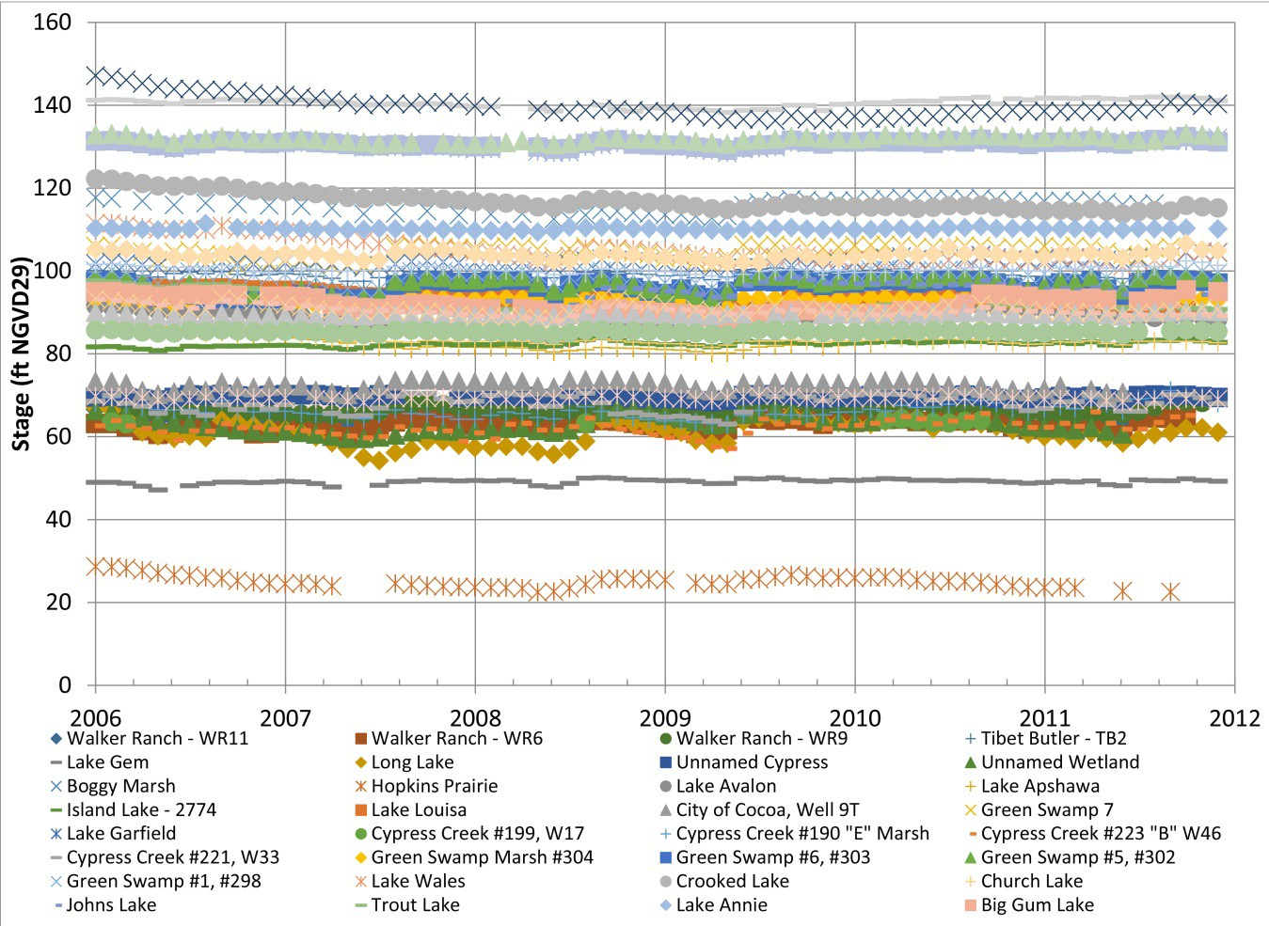

**Figure 15. Stage record hydrographs for 44 Class 1 wetlands used in the EMT study.**

require a longer period of time to capture the full range of water level fluctuations. This aspect of the data set is acknowledged, but the relative scarcity of available data of sufficient quality during study design necessarily limited the number and type of sites. Errors introduced by differing periods of record would be engrained into the analysis if the full range of available data were used. In order to minimize such inconsistencies caused by differing periods of record, a standard period, from 2006 to 2011, was selected as the best compromise between adequate duration of record and maximum number of sites for which an adequate record was available. CFD plots of hydrologic data for stage relative to wetland edge (WE) elevation were developed based on these data for stressed and unstressed wetlands within the ridges and plains physiographic provinces (**Figures 16 and 17**).

This methodology was similar to that used by the SWFWMD to develop MFL criteria (SWFWMD, 1999). The hydrologic data analysis indicated that the cumulative range of wetland and lake water level fluctuation was greater in the ridge wetland systems relative to the plains systems. As a population, unstressed plains systems had a long term average P80 of 2.7 ft. below the wetland edge while stressed systems had an average long‐term P80 of 5.1 ft. below the wetland edge. Assuming that the unstressed plains population has a normal distribution, plains wetlands with a long‐term P80 more than 4.5 ft. below the edge are likely not to belong to the population of unstressed systems more than 2.5% of the time (i.e., they are in the tail end of the distribution that includes only 2.5% of the wetlands), and wetlands with long‐term P80 values of 5.1 ft. or more below the edge are not expected to be in the population of unstressed wetlands more than 0.5% of the time.

29 November, 2013

**Figure 16. Plains physiographic region average cumulative frequency distribution plot of hydrologic data for stage relative to wetland edge (WE) elevation for stressed and unstressed wetlands, based on water level records from 2006‐2011.**

0

‐2

‐4

‐6

‐8

‐10

‐12

0

20

40

60

80

100

**Percent of Time Stage is Exceeded**

Mean ‐ Unstressed Plain Mean ‐ Stressed Plain

0

‐2

‐4

‐6

‐8

‐10

‐12

0

20

40

60

80

100

**Percent of Time Stage is Exceeded**

Mean ‐ Unstressed Ridge Mean ‐ Stressed Ridge

**Stage Relative to WE (ft)**

**Stage Relative to WE (ft)**

**Figure 17. Ridge physiographic region average cumulative frequency distribution plot of hydrologic data for stage relative to wetland edge (WE) elevation for stressed and unstressed wetlands, based on water level records from 2006‐2011.**

Unstressed ridge systems had a long term average P80 of 3.4 ft. below the wetland edge, while stressed systems had an average long‐term P80 of 7.4 ft. below the wetland edge. Assuming that the unstressed ridge population has a normal distribution, ridge wetlands with a long‐term P80 more than 6.4 ft. below the edge are likely not to belong to the population of unstressed systems more than 2.5% of the time, and wetlands with long‐term P80 values of 7.3 ft. or more below the edge are not expected to be in the population of unstressed wetlands more than 0.5% of the time.

Wetlands can also be inundated to an extent that may cause stress and assuming normal distributions for the unstressed plains and ridge wetlands, those with long term P80 values higher than approximately 1 ft. below the wetland edge are estimated to be stressed approximately 2.5% of the time in both physiographic settings. (See **Appendix G**).

November, 2013 30

**Sample sites compared to the overall population of wetlands**

The objective of this analysis was to examine the spatial characteristics of the wetland sites being used by the EMT in its examination of the relationships between their hydrologic characteristics and the probability of stress. This is an important consideration to understand how representative the sample of assessed wetlands was to the whole population of wetlands in the CFWI. Wetland area and perimeter data were obtained from geospatial land use maps (2004 to 2006 updates) obtained from the three water management districts. Because different vegetation types within a wetland were mapped, as well as open water areas, GIS processing was conducted to dissolve these different polygons into a single unit. All wetlands represented in these databases were included in this analysis. Stressed wetland sites were defined by the EMT (see above). The classification system used to identify wetland sites with similar data availability, as described in **Attachment E**, was used in this analysis.

The spatial characteristics of the wetland sites within the CFWI boundary included the following:

* + Area
  + Perimeter
  + Area: Perimeter ratio
  + Elevation
  + Land use

The Land Development Index (LDI) as developed by Brown and Vivas (2005) was used to describe the proximal land uses within the area surrounding each wetland. The FLUCCS land use codes (FDOT, 1999) as obtained from the water management district databases were converted into the Landscape Development Intensity (LDI) Index. The LDI index was calculated from land use data and a development intensity measure derived from energy use per unit area in order to estimate the potential impacts from human dominated activities within watersheds. The LDI index ranges from 1‐10, with 10 being the most developed (Brown and Vivas, 2005). In order to gain an understanding of the LDIs in proximity to the wetlands, the LDI Index within the ECFT groundwater model cell associated within each wetland in the CFWI was calculated. **Attachment A** presents the cross‐walk between the FLUCCS codes and the associated LDI.

Statistical analyses were conducted to examine water surface elevations, described as frequency distributions, which best discriminate stressed from non‐stressed wetlands. Results of these analyses (**Attachment F**) suggested that the difference between the field‐observed wetland edge (WE) and the 80th percentile (P80) of water surface elevations [WE‐P80] calculated from a cumulative frequency distribution was the best choice to discriminate between stressed and non‐stressed wetlands. A list of P80 values relative to the wetland edge for the 44 sites is provided in **Table 1** (above). A summary for stressed and unstressed plains and ridges isolated systems is provided in **Attachment G, Table G‐2**.

***Wetland classes by information level***

Based on a review of monitoring data from stressed and unstressed wetland systems, the EMT concluded that there were sufficient data available to support statistical assessment of the likelihood of inducing stress given a level of surface water drawdown. Wetlands that were used in this analysis were divided into plains and ridge systems. Only wetlands that were classified as being isolated systems (see **Attachment E**), which comprise about 27% of the total wetland acreage within the CFWI, were included

31 November, 2013

because they are not interconnected or flowing systems that may be less sensitive to localized groundwater withdrawals. It was assumed that these isolated were likely the wetland types most sensitive to altered groundwater level.

Wetlands within the CFWI can be divided into three classes based on the amount of information available, as summarized in **Table 3**.

* Class 1 includes 44 wetlands (Figure 14) that were studied in detail as part of this investigation, have known hydrologic conditions (water level variability and wetland edge elevation) and have been assessed to determine whether they are currently stressed or unstressed.
* Class 2 consists of 313 sites where the environmental condition of the wetland is known, but there is insufficient water level data to classify their hydrologic conditions. See Figure 10 for locations of Class 1 and Class 2 sites combined.
* For most of the remaining thousands of isolated and hydrologically unaltered wetlands in the region (Class 3), neither the water levels nor the stress conditions are known.

**Table 3. Descriptions of wetland data classes based on available information**

|  |  |  |  |  |
| --- | --- | --- | --- | --- |
| **Wetland Data Class** | **No. of Wetlands** | **Data Class Characteristics** | | |
| **Wetland Type** | **Current Stress Condition** | **Water Level Hydrograph** |
| **Class 1** | 44 | Known | Known | Known |
| **Class 2** | 313 | Known | Known | Unknown |
| **Class 3** | (thousands) | Known | Unknown | Unknown |

***Statistical distribution of the indicator variable***

As discussed previously, the value of WE‐P80 is its use as an indicator variable to identify wetland stress. The statistical distribution of this indicator was examined to determine its characteristics. Statistical distributions were fitted to observations of wetlands that had sufficient available data (Class 1). The following numbers of wetlands were used for each of the four categories:

* + 10 plains wetlands, unstressed
  + 8 plains wetlands stressed
  + 15 ridge wetlands unstressed
  + 11 ridge Wetlands Stressed

## Model Output Evaluations

**Surface water changes in wetlands under modeled scenarios**

Model simulations of future water withdrawals (2015, 2025, 2035 and End‐of‐Permit) were used to calculate surface water level changes in assessed wetlands to examine potential impacts under these scenarios. Please refer to HAT and GAT documentations for descriptions of modeling scenarios and outputs. The mean water level was calculated for each EMT wetland assessment site from monthly model outputs from modeled scenarios. The difference between the mean surface water level for the reference condition (2006) and a future modeled condition was used to determine if wetland water levels would be expected to increase, decrease or remain the same under the future condition. The magnitudes of water level change from a reference condition, at assessed wetland sites, were mapped to indicate areas of greatest change.

November, 2013 32

**Statistical assessment for risk of inducing stress in wetlands**

Using the Class 1 data set of 44 wetlands, statistical analyses were performed to develop a relationship for the likelihood of stress as a function of water levels. The ECFT groundwater model was used to assess the likely amount of future change in groundwater levels under various model scenarios. The statistical relationship for risk of wetland stress as a function of water levels was then used to estimate the probability that any given wetland would change stress status as a result of future projected changes in groundwater levels.

For the Class 1 wetlands, it was possible to estimate a site‐specific probability that a wetland would change stress status based on its own site‐specific history of water levels and projected future changes in those water levels. For Class 2 wetlands, the historical range of water levels at each wetland is unknown, but the current stress status is known. It was thus possible to calculate a population‐ weighted average risk of stress status change by assuming that the statistical distribution of historical water levels can be estimated from those observed in Class 1 wetlands.

The approach for Class 3 wetlands (which represent the majority of isolated and not hydrologically altered plains wetlands and isolated ridge wetlands in the study area) was similar to that used for Class 2 wetlands, except that the initial stress status of the wetlands was unknown. The statistical distribution of currently stressed and unstressed wetlands was estimated for the Class 3 data set by assuming similar statistical distributions of stress to those observed in the other two data sets (see **Attachment F**). Once this factor was applied, the Class 3 data set was divided into estimated percentages of currently stressed and unstressed wetland area; the method is the same as for the Class 2 wetland systems.

In the field assessment, wetlands were identified as being substantially hydrologically altered (SHA) if there were obvious conditions or features that would have changed the water levels. For further discussion and examples see the section entitled “Hydrologic Alterations.” The presence of stress in plains wetlands was related to hydrologic alteration (94% of SHA plains wetlands were stressed, as compared to 18% of non‐SHA plains wetlands). Because of this, hydrologically altered plains wetlands were excluded from this analysis, since the extent to which changes in groundwater withdrawals might or might not affect their future stress status cannot be assessed. Unlike the plains wetlands, observed hydrologic alteration in ridge wetlands was not found to cause a significantly different incidence of stress. Because of this, ridge wetlands with SHA were included in the analysis.

***Estimation of future alterations in wetland water levels***

The ECFT groundwater model is not an integrated surface water/groundwater model and thus does not simulate the surface water inflow and outflow components of wetland hydrology. However, it does track the overall split of rainfall into runoff, evapotranspiration and groundwater recharge, and it simulates the resulting changes in groundwater potentiometric elevations. Most of the plains physiographic provinces are characterized by strongly confining, regionally consistent conditions in which there is significant resistance to exchange of water between the surficial aquifer system and the underlying Floridan aquifer system. For plains wetlands, review of the hydrologic conditions and review of the ECFT model results both led to a conclusion that the best predictor for change in the long term water level regime of the wetlands due to groundwater alterations is the simulated change in the surficial aquifer water table at the wetland location.

33 November, 2013

Most of the ridge physiographic provinces are characterized by less confining conditions that vary considerably at the local scale. The ECFT groundwater model was unable to reproduce this scale of variability, both because the variability occurs at a finer scale than the model grid cells, and because there is insufficient data available to provide calibration information on all the local variations in confinement and resulting water table elevation differences. Typically, there is more water table information available for surface water bodies (lakes). In addition, lakes are often located in relatively‐ leaky, karst depressional features that provide connections and allow transfer of water between surface or surficial aquifer water and deeper aquifers including the Floridan. Consequently, the water table elevations and the semi‐confining conditions that produce them are represented in the model at a scale that may preferentially represent leakier areas of the ridge physiographic region. Some of the water and wetland features in the ridge physiographic provinces are located on extremely leaky local features that will be leakier than the surrounding areas, and that will not be fully captured by the model calibration. Because of these competing effects, and the uncertainty associated with them, future changes to ridge wetlands were estimated using a bracketing approach. One side of the bracket was the projected change in surficial water table elevations from the ECFT model, which may under‐estimate wetland water level response to groundwater drawdown in the leakiest locations. The other side of the bracket was the projected change in upper Floridan aquifer potentiometric elevations from the ECFT model, which will over‐estimate wetland water level response to groundwater drawdown in the Floridan aquifer in many locations. These two approaches yield a best estimate of “best case” and “worst case” future changes in ridge wetland water levels from which to estimate corresponding probabilities of changes in wetland stress conditions.

***Use of accumulated probabilities of wetland stress status***

The calculations of the likelihood of changes in stress status for Class 2 and Class 3 wetlands depend on population‐weighted average functions for response to predicted changes in water levels, as discussed above. A review of the stress response functions for the Class 1 wetland data set shows that the probability of inducing stress with any specified level of water change depends very strongly on the initial conditions of water levels in the wetland being examined. For instance, a drawdown change of

0.5 feet in the wetland water level shows a probability of inducing stress in a plains wetland of only 3% if the initial water levels are close to an ideal condition for plains wetlands; but that same change of 0.5 feet in the wetland water level can produce an almost 100% probability of inducing stress in a plains wetland if the initial water level conditions are already significantly lower than the ideal range for plains wetlands. The response is extremely sensitive to initial hydrologic conditions of the wetlands, which is an unknown aspect of the Class 2 and Class 3 wetland systems. For this reason, the predicted probabilities of inducing stress are not very helpful for assessing individual (i.e., site‐specific) risk of future stress status change in Class 2 and Class 3 wetlands. Instead, we chose to accept a large level of local prediction uncertainty, and rely on the law of averages to provide a better prediction of probability of future stress at a regional scale. By summing the effects of all the local calculations of probable future stress change probabilities, the random errors of over‐prediction and under‐prediction tend to cancel each other, and the regional sum of the effects is much less subject to large errors than any of the local‐scale predictions. For this reason we believe that the results of this analysis are only useful for Class 2 and Class 3 wetlands when considered from the regional scale of summed regional estimate of overall change in stress status.

November, 2013 34

# Summary of Findings

## Spatial Distribution of Wetlands in the CFWI

A map of the distribution of wetlands within the CFWI is shown in **Figure 18.** The numbers of wetlands, areas and percentages of the CFWI represented by the various wetland classifications (see **Attachment**

**E**) are summarized in **Table 4.** The wetland type with the largest extent in the CFWI included floodplain and interconnected wetlands (2F and 2D). In contrast, flats wetlands (1D) and flatland lakes (1E) covered the least extent. The greatest numbers of wetlands were the isolated and semi‐isolated mesic systems (1A and 2‐A‐M).

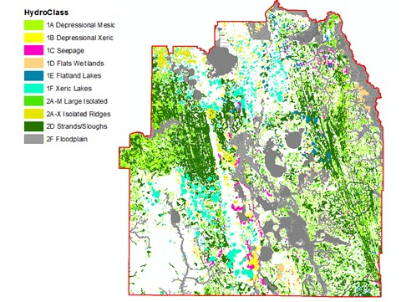

**Figure 18. GIS analysis of wetlands within the CFWI showing spatial distribution of wetlands by hydroclass.**

**Table 4. Total acreages and percentage coverages of wetland hydroclasses (types) within the CFWI, based on the GIS analysis.**

|  |  |  |  |
| --- | --- | --- | --- |
| **Type** | **Description** | **Acreage % Total Wetland Acres** | |
| **1A + 2A‐M + 1E** | **Isolated and semi‐isolated mesic (plains)** | **169,000** | 15.7 |
| **1B + 2A‐X + 1F** | **Isolated and semi‐isolated xeric (ridges)** | **119,000** | 11.1 |
| **1C** | **Slope (seepage)wetlands** | **22,000** | 2.1 |
| **\*\*1D** | **Flats wetlands (ridges, plains and floodplains)** | **26,000** | 2.4 |
| **2D\*** | **Connected‐(strands/sloughs‐ridges and plains)** | **279,000** | 25.9 |
| **2F\*** | **Floodplain (lakes and wetlands)** | **461,000** | 42.8 |
| **TOTALS** | | **1,076,000** | **100** |

35 November, 2013

## Current Status of Stressed and Unstressed Wetlands in the CFWI

Of the wetlands that were assessed, 357 had sufficient data to allow a determination of stress and hydrologic alteration. Of these, 234 did not have obvious hydrologic alteration and when mapped, showed a pattern of stress along the U.S. 27 corridor, in the SWFWMD Southern Water Use Caution Area, in western Orange and southeastern Lake Counties, and on ridge areas such as the Winter Haven Ridge in Polk County. The wetlands used in this analysis are shown in **Figure 19.** These correspond to those Class 1 and Class 2 wetlands used in other analyses that are located within the CFWI boundary.

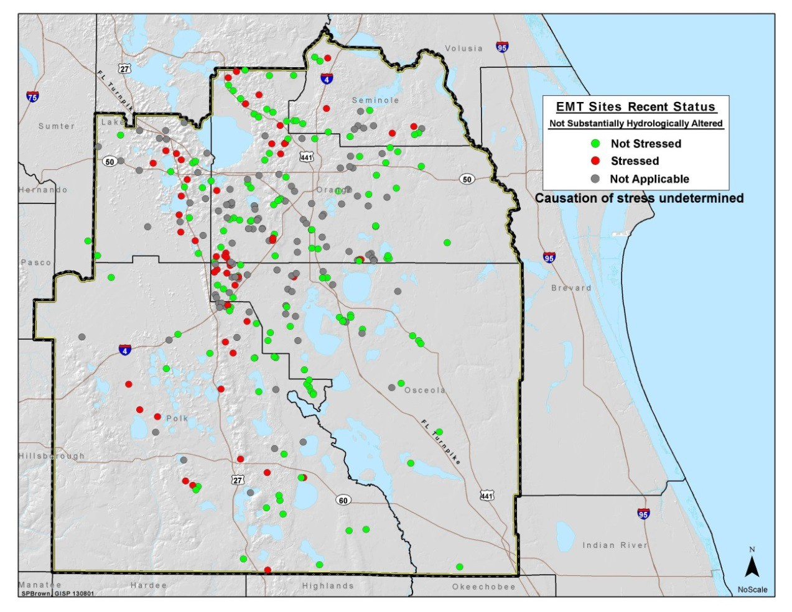

**Figure 19. Locations of Class 1 and Class 2 EMT field‐assessed wetlands within the CFWI boundary. Green dots = wetlands that were identified as unstressed; Red dots = wetlands identified as stressed; Grey dots = stress condition was not identified or wetland had observed hydrologic alteration.**

## Wetland Analysis under Future Modeled Scenarios

**Class 1 and class 2 wetlands within the CFWI study area boundary**

***Modeled 2015 conditions***

Under the modeled 2015 simulation, the changes in surface water elevations at EMT wetland sites (as compared to the modeled 2005 reference condition) are shown in **Figure 20.** The wetland sites have been color coded to indicate the degree of water level change under the modeled conditions. Negative values indicate a decrease in water elevations, positive values indicate an increase in water elevations and values that ranged between ‐0.2 to +0.2 ft. were not considered to indicate a trend since the model may not be able to resolve that level of detail throughout the model domain. For these maps, values between 0.2 and 1.0 ft. may indicate a water level trend under the model condition but care is urged in

November, 2013 36

recognizing model limitations. As model output values show changes that increase above 1.0 ft. difference from the reference condition, there is more likelihood that water elevations will change in the indicated direction and these sites should be regarded as those of most interest.

Water levels in EMT wetlands along the upper and lower U.S. 27 corridor, in western Orange and southeastern Lake County, and in eastern Polk County showed a trend of decreasing surface water elevations (‐1.0 to ‐0.2 ft.) in the modeled 2015 simulation relative to the reference condition (**Figure 20**). Approximately 25 percent of the EMT‐assessed wetlands had modeled drawdown between ‐1.0 to ‐

0.2 ft. Five assessed wetlands (1 percent of all EMT sites) had water level decreases of 1 ft. or more. Lowered simulated water elevations appear in wetlands that are currently stressed and unstressed (**Figure 21**). However not all wetlands had declining water elevations. Near southeastern Lake, northeastern Polk and northwestern Osceola counties, water elevations show an increasing trend in several wetlands.

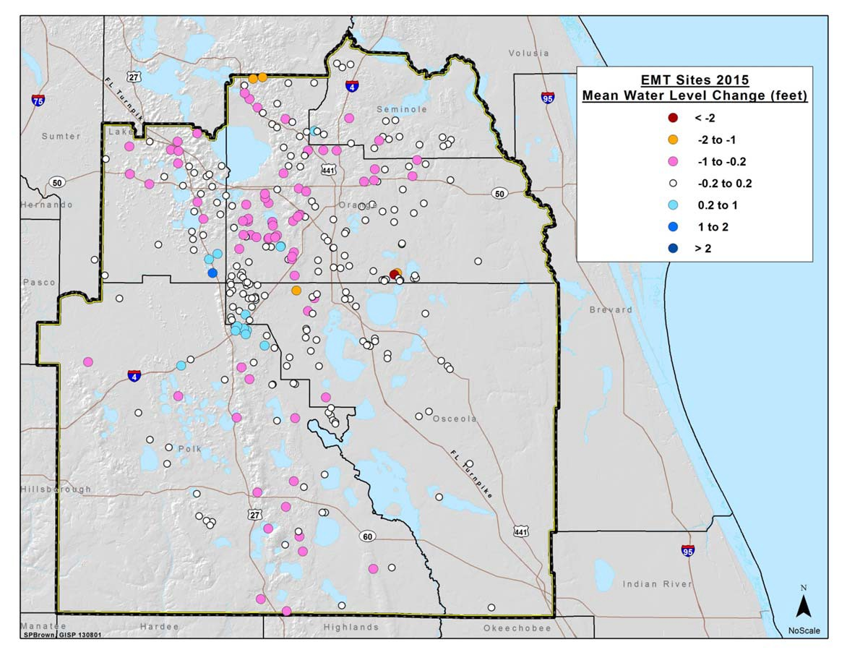

**Figure 20. EMT field assessed wetlands within the CFWI, boundary, indicating projected 2015 water elevations changes relative to the reference condition.**

37 November, 2013

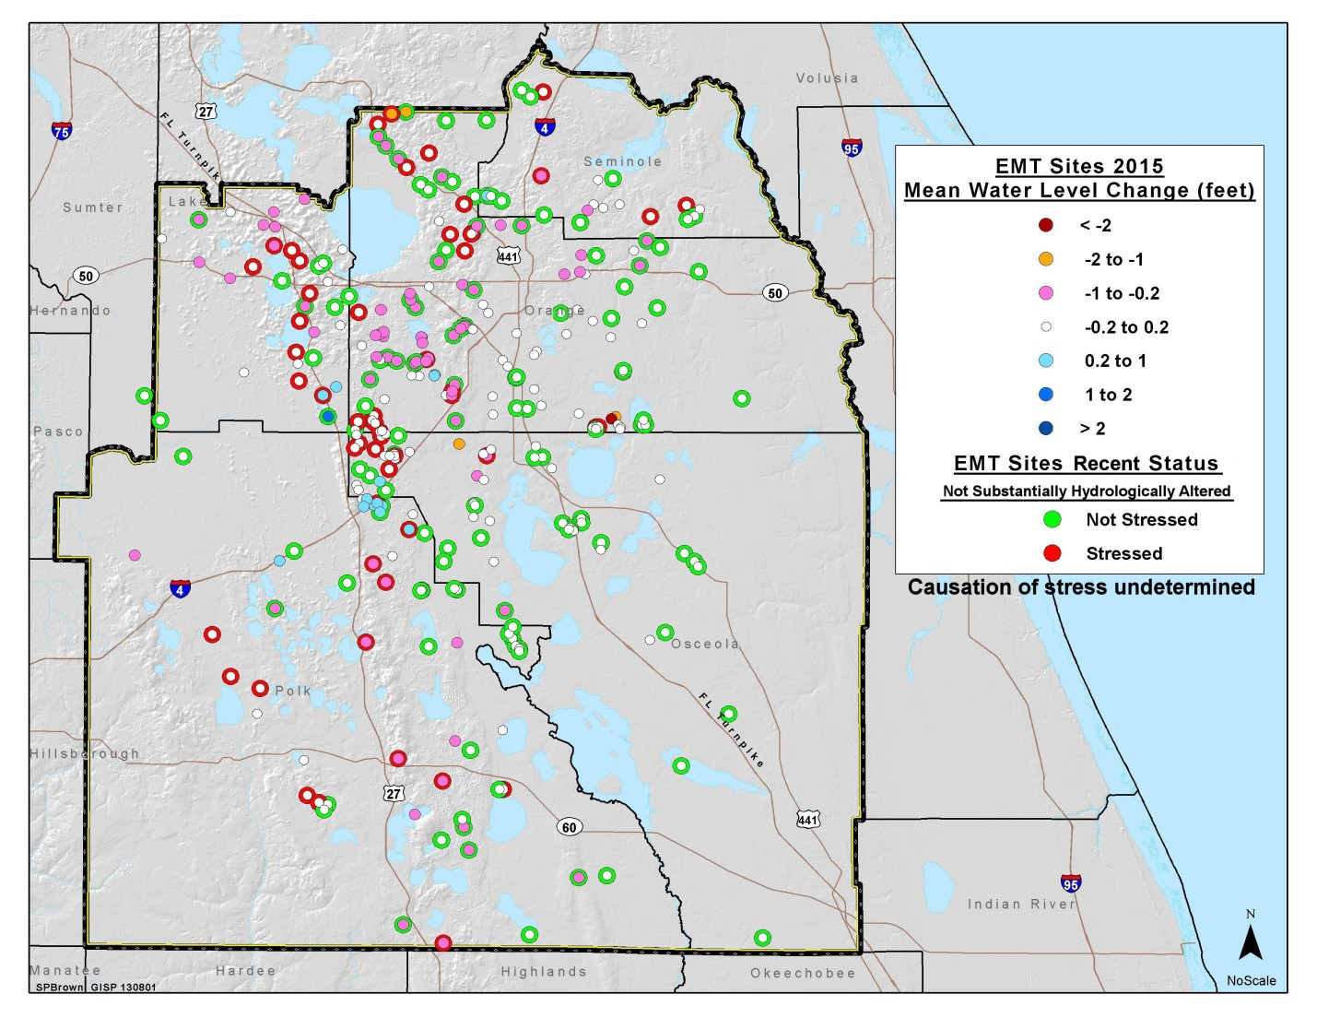

**Figure 21. EMT field assessed wetlands within the CFWI boundary, indicating recent stress condition and projected 2015 water elevations changes relative to the reference condition.**

***Modeled 2025 conditions***

Under the modeled 2025 simulation, surface water levels at EMT wetlands decreased substantially from the reference condition (**Figure 22**). Although water elevations decreases were centered on the same areas seen in the 2015 simulation (**Figure 20**), by 2025, the spatial extent increased. In the 2025 simulation, 32 percent of the EMT assessed wetlands had modeled drawdown between ‐1.0 to ‐0.2 ft. and 58 wetlands (17 percent of all EMT sites) had water elevations decreases of 1 ft. or more. Lowered simulated water elevations appear in wetlands that are currently stressed and unstressed (**Figure 23**) and there were fewer sites with increased water elevations as compared to the 2015 simulation (**Figure 21**).

November, 2013 38

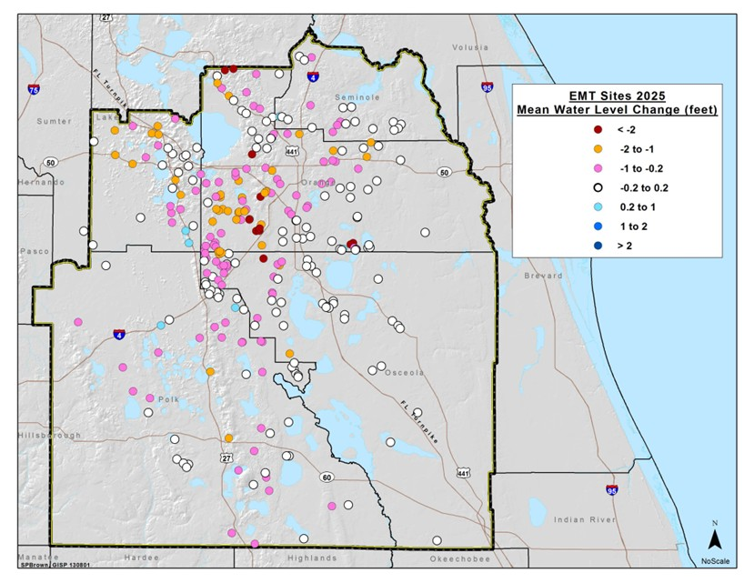

**Figure 22. EMT field assessed wetlands indicating projected 2025 water elevation changes relative to the reference condition.**

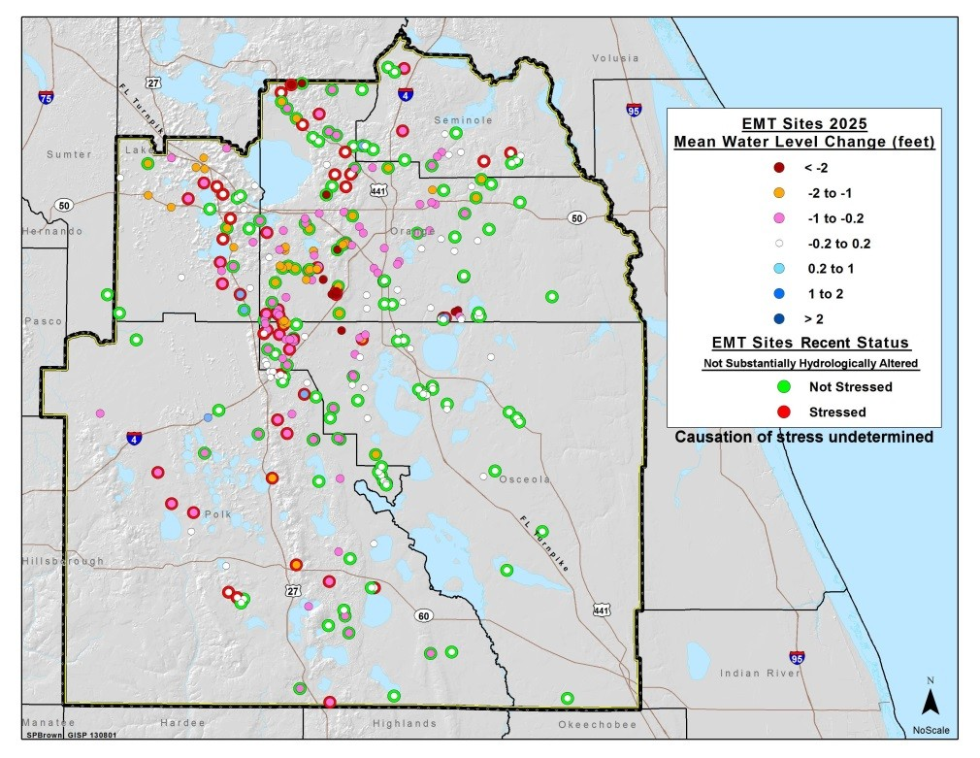

**Figure 23. EMT field assessed wetlands indicating recent stress condition and projected 2025 water elevation changes relative to the reference condition.**

***Modeled 2035 and end of permit (EOP) conditions***

Under the modeled 2035 and EOP simulations there is little difference in outcomes between the two model runs (**Figures 24 and 25** compared to **Figures 26 and 27**). In these scenarios, approximately 30 percent of EMT wetlands experience surface water elevations that are between ‐1.0 to ‐0.2 ft. lower

39 November, 2013

than occur in the reference condition and 24 percent to 30 percent of wetlands (40‐50 sites) had water elevations decreases equal to or greater than 1.0 ft.

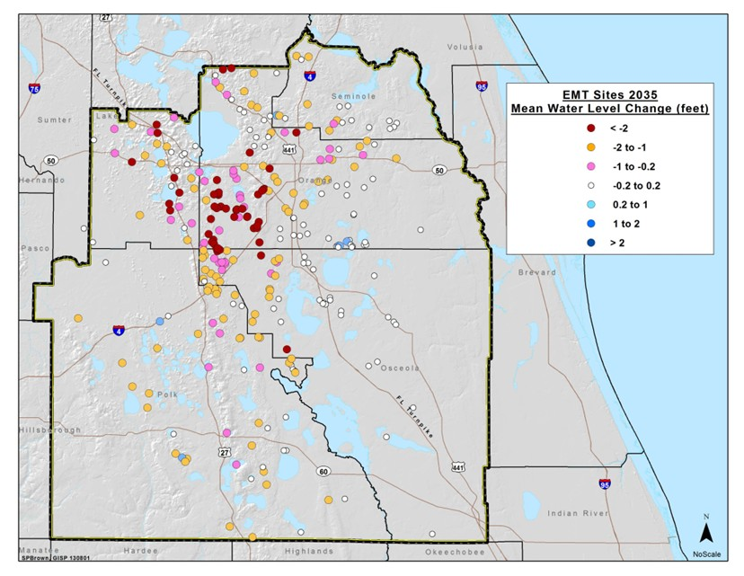

**Figure 24. EMT field assessed wetlands indicating projected 2035 water elevation changes relative to the reference condition.**

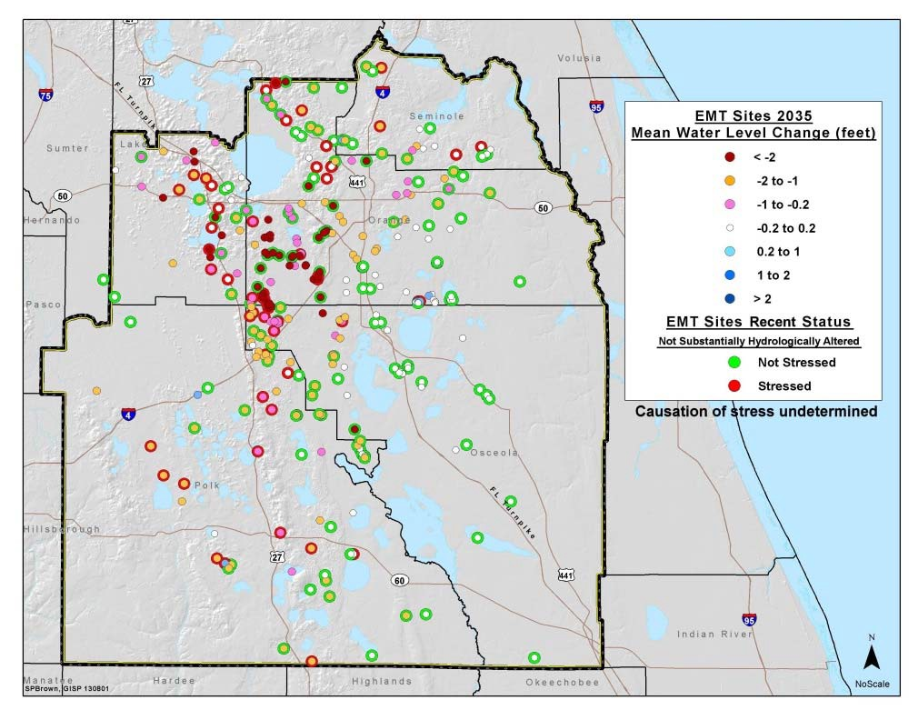

**Figure 25. EMT field assessed wetlands indicating recent stress condition and projected 2035 water elevation changes relative to the reference condition.**

November, 2013 40

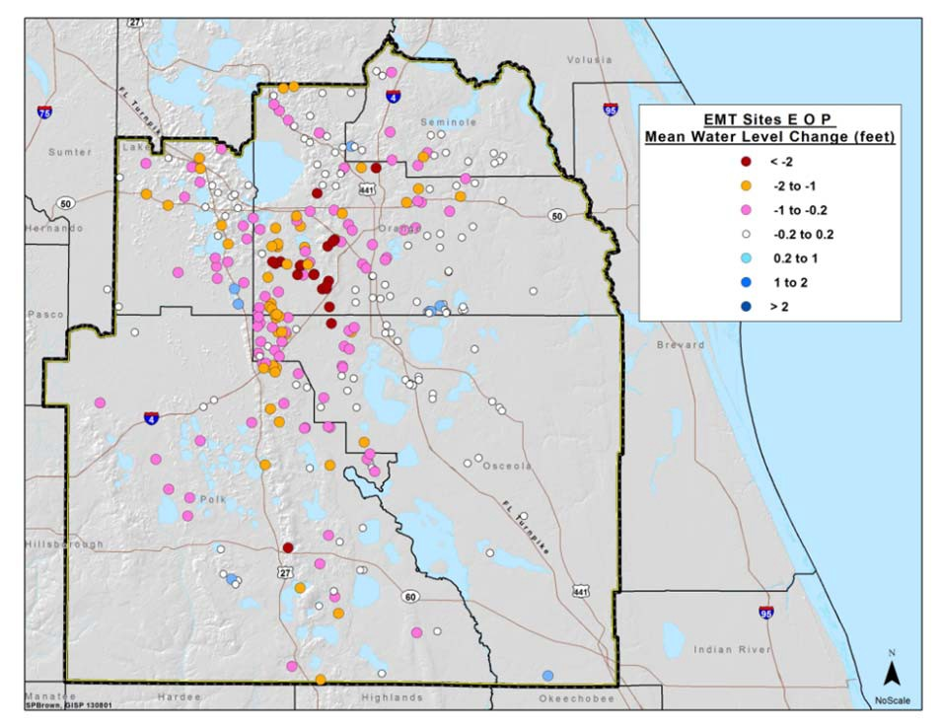

**Figure 26. EMT field assessed wetlands indicating projected End‐of‐Permit water elevation changes relative to the reference condition.**

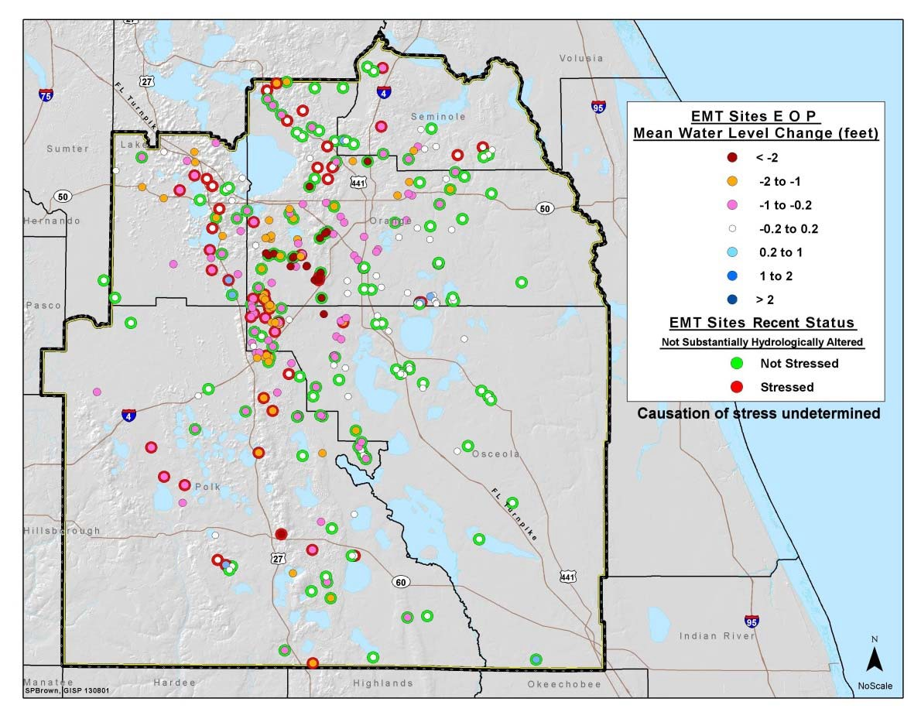

**Figure 27. EMT field assessed wetlands indicating recent stress condition and projected End‐of‐Permit water elevations changes relative to the reference condition.**

41 November, 2013

**Risk assessment of wetlands**

As stated previously, isolated wetlands were studied because they are believed to be the most hydrologically sensitive wetland type. Isolated wetlands comprise approximately 27 percent of the total wetland acreage within the CFWI (Table 4). **Table 5** shows the results of the predicted regional scale changes in stress conditions for the 82,000 acres of isolated plains wetlands that do not have significant hydrological alterations and **Table 6** shows similar results for 92,000 acres of isolated ridge wetland systems.

**Table 5. Summary of results for regional assessment of the area of stressed plains wetlands, excluding wetlands with significant hydrologic alteration.**

|  |  |  |  |  |  |  |
| --- | --- | --- | --- | --- | --- | --- |
| **Wetland Class** | **Total Area (acres)** | **Stressed Wetland Acreages for Each Simulation** | | | | |
| **2005** | **2015** | **2025** | **2035** | **EOP\*** |
| **Class 1** | 510 | 460 | 240 | 300 | 460 | 320 |
| **Class 2** | 2,600 | 1,400 | 1,500 | 1,600 | 1,600 | 1,600 |
| **Class 3** | 79,000 | 14,000 | 15,000 | 16,000 | 17,000 | 16,000 |
| **Total** | **82,000** | 16,000 | 17,000 | 18,000 | 19,000 | 18,000 |

* Class 1 acreages were rounded to the nearest 10 acres; Class 2 to the nearest 100 acres; and Class 3 to the nearest 1000 acres, based on the relative quality of data obtained from GIS and field data for each class

**EOP = End‐Of‐Permit

**Table 6. Summary of results for regional assessment of the area of stressed isolated ridge wetlands, including wetlands with significant hydrologic alteration (see text).**

|  |  |  |  |  |  |  |  |
| --- | --- | --- | --- | --- | --- | --- | --- |
| **Aquifer Layer Used to Predict Wetland Water Level Change** | **Wetland Class** | **Total Area (acres)**  **\*\*** | **Stressed Wetland Acreages for Each Simulat** | | | | **ion** |
| **2005** | **2015** | **2025** | **2035** | **EOP\*\*** |
| **Class 1** | | 18,300 | 13,420 | 13,480 | 13,640 | 13,880 | 13,690 |
| **Surficial** | **Class 2** | 9,800 | 2,800 | 3,300 | 3,900 | 4,900 | 4,200 |
| **Aquifer System** | **Class 3** | 64,000 | 25,000 | 27,000 | 29,000 | 32,000 | 30,000 |
|  | **Total** | **92,000** | **41,000** | **44,000** | **47,000** | **51,000** | **48,000** |
| **Class 1** | | 18,300 | 13,420 | 13,860 | 14,740 | 16,400 | 16,440 |
| **Upper Floridan** | **Class 2** | 9,800 | 2,800 | 3,800 | 6,000 | 8,400 | 7,000 |
| **Aquifer** | **Class 3** | 64,000 | 25,000 | 31,000 | 38,000 | 45,000 | 43,000 |
|  | **Total** | **92,000** | **41,000** | **49,000** | **59,000** | **70,000** | **66,000** |

* Class 1 acreages were rounded to the nearest 10 acres; Class 2 to the nearest 100 acres; and Class 3 to the nearest 1000 acres, based on the relative quality of data obtained from GIS and field data for each class

**EOP = End‐Of‐Permit

Wetland vulnerability to impacts from Floridan Aquifer withdrawals is driven by two primary considerations: (i) the environmental sensitivity of the wetland to a given level of surface water level change, and (ii) the sensitivity of the wetland water level to a given change in Floridan Aquifer withdrawals.

In general, plains wetlands are more environmentally sensitive to water level change, in the sense that a smaller change is sufficient to move an unstressed plains wetland from a non‐stressed hydrologic

November, 2013 42

condition to a condition where stress is very probable. However, this is offset by the distribution of initial water levels: on average, unstressed plains wetlands tend to start from a current hydrologic status that is closer to their ideal hydrologic condition compared to unstressed ridge wetlands. As a result, the population‐weighted sensitivity to drawdown from the reference condition is very similar for both unstressed plains and unstressed ridge wetlands.

On the second factor, vulnerability of surface water levels to being affected by drawdown in the Floridan Aquifer, the ridge wetlands are much more likely to be located in leaky locations where surficial water levels are strongly affected by underlying Floridan Aquifer water level changes. The net effect is that the plains wetlands show relatively little overall sensitivity to future projected increases in Floridan aquifer withdrawals. This is reflected in the results which show that projected withdrawals in 2035, which are about 50% larger than those in the 2005 reference condition, increase the projected total acreages of stressed plains wetland area from 16,000 for the reference condition to 19,000 for the 2035 condition (**Table 5**): an increase of 4% of the portion of the isolated plains wetland population that was assessed in this study. The same change of withdrawals increases the projected total area of stressed ridge wetland area from 41,000 acres in the reference condition to somewhere between 51,000 and 71,000 acres in the 2035 condition (**Table 6**): an increase of 11% to 33% of the portion of the isolated ridge wetland population that was assessed in this study.

Given the relative insensitivity of the plains wetlands to projected groundwater withdrawal increases, the relatively high incidence of stress in the current condition is notable, and it suggests that plains wetlands are more vulnerable to stress from other causes. The incidence of stressed plains wetlands is 94% for plains wetlands that were identified as substantially hydrologically altered, compared to 18% for plains wetlands that were not identified as substantially hydrologically altered. In addition, the incidence of substantially hydrologically altered wetlands is much higher in urban environments than in rural environments. In the lowest urban density areas, 7% of the observed wetlands were classified as substantially hydrologically altered, compared to 35% and 43%, respectively, for moderate and high urban density environments. This shows that substantial hydrologic alteration is a very strong predictor of plains wetland stress, and that urbanization is a very strong predictor of substantial hydrologic alteration. Even the wetlands that were not identified as substantially hydrologically altered show a pattern of increased incidence of stress with increasing urban density (15%, 18% and 25% for low, moderate and high urban density areas, respectively.). The trend of increasing stress with increasing urban density may not be statistically significant for plains wetlands that were not identified as substantially hydrologically altered, but it is suggestive, especially when combined with the pattern of substantial hydrologic alteration.

It is important to note the limitations of this analysis in assessing the probability of wetland stress occurring at the local scale. The regional scale of the groundwater model limits its precision in predicting future changes of water elevations in specific local water bodies and wetland systems. In addition, the wetland stress response is very sensitive to the initial hydrologic condition of each wetland, and this is not known at a site‐specific level for most of the wetlands. We have sought to minimize the effects of both types of uncertainty by averaging the effects across the entire model domain. This tends to reduce the overall effect of random errors because randomly distributed positive and negative errors at individual locations tend to cancel each other when predicted effects at individual locations are summed across the region to obtain a predicted net regional effect.

Lastly, the projections of wetland stress are specific to the particular distribution of projected future groundwater withdrawals and recharges. These factors are expected to change during the solutions planning phase of the CFWI process, so that the final projections of future wetland stress will be different from those presented here.

43 November, 2013

# Conclusions, Appropriate use of Findings, and Recommendations

Results from these analyses indicated that there are areas within the CFWI where there currently are stressed wetlands, particularly along the U.S. 27 corridor, western Orange County, southeastern Lake County and in Polk County west of the Lake Wales Ridge (associated with the Southern Water Use Caution Area). Model scenarios of future conditions (2015, 2025, 2035 and End of Permit) indicated that the number and extent of stressed wetlands would increase in these areas and expand into areas where wetlands are currently not stressed. Map products and analyses results were provided to the GAT to support their task of quantifying the amount of groundwater that may be currently available in the study area. It is anticipated that these tools will be applied to other model scenarios during the solutions phase of the CFWI effort.

It is important to understand the limitations of this analysis and the appropriate use of these findings. Some of the limitations inherent in this study included:

* + Statistical analyses were performed, which indicated that the characteristics of the 44 sampled wetlands were sufficiently representative of all isolated wetlands in the CFWI and that the data used were appropriate for their application.
  + The EMT focused on hydrologically isolated systems because they are generally viewed as being a wetland type that is more sensitive to groundwater changes than interconnected or flowing systems. Examples of isolated wetlands are found throughout the CFWI area. If these more sensitive wetlands are protected, it is assumed that less vulnerable systems will also be protected.
  + Isolated systems only represent a small percentage of the total number of wetlands in the study area and, therefore, it would be inappropriate to extrapolate their percentage of wetlands impacted to all wetlands in the CFWI.
  + The patterns of response seen in the results of these analyses generally appear to agree with results we would expect to see in the landscape, based on experience to date.
  + This study did not address the severity of wetland stress, which can also be an important factor when considering the impact of human activities on natural systems.
  + These conclusions were based on East Central Florida Transient Model output and are subject to limitations of modeling assumptions and available input data.
  + Although obvious factors that could affect wetland water levels were identified and wetlands with these impacts were not included in the analysis, other factors that were not considered can also degrade wetland quality, such as the invasion of non‐native species, nutrient enrichment, changes to drainage patterns, and land management activities, many of which are associated with urbanization and agriculture.
  + These analyses were conducted to support the water supply planning process and are at the scale and resolution appropriate for that effort; use of these findings in other contexts or for other applications (e.g., permitting and regulatory activities) would likely require additional data acquisition, analysis and considerations.
  + It is important to note that the findings of the EMT are based on a specific set of model scenarios that will change during the solutions phase of the CFWI effort. As such, the projected future conditions will change.

November, 2013 44

* + Maps and analysis results are intended to be applied at landscape‐level scales to systems that are hydrologically and biologically similar to the wetland sites studied; application to smaller scales and other types of wetlands may be appropriate, however this is subject to data availability, quality constraints, and field verification.

Future data collection efforts in this region could support the collection of a more robust data set for these types of analyses. Better characterizations of wetland water levels at stressed and unstressed sites would be achieved by additional monitoring sites, particularly in areas where future wetland stress may be a concern or current wetland stress may be alleviated. It is anticipated that the findings from this study will also inform the DMIT, especially for identifying areas where sufficient monitoring may be lacking.

45 November, 2013

# References

Armentano, Thomas V., Jay P. Sah, Michael S. Ross, David T. Jones, Hillary C. Cooley, and Craig S. Smith.

2006. Rapid responses of vegetation to hydrological changes in Taylor Slough, Everglades National Park, Florida, USA. Hydrobiologia 569(1):293‐309.

Bernhardt, Christopher E. and Debra A. Willard. 2009. Response of the Everglades ridge and slough landscape to climate variability and 20th‐century water management. Ecological Applications 19(7):1723–1738.

Brandt, Karla and Katherine C. Ewel. 1989. Ecology and management of cypress swamps: a review.

Florida Cooperative Extension Service, Institute of Food and Agricultural Sciences, University of Florida, Gainesville, FL. Bulletin 252 , May 1989. 21 pp.

Brinson, Mark M. 1993. A hydrogeomorphic classification for wetlands. Wetlands Research Program Technical Report WRP‐DE‐4. U.S. Army Corps of Engineers, Waterways Experiment Station, Vicksburg, MS.

Brooks, H.K. 1981. Physiographic divisions of Florida (map). Institute of Food and Agricultural Sciences.

University of Florida, Gainesville, Fla., 1p.

Brown, Mark T. and M. Benjamin Vivas. 2005. Landscape development intensity index. Environmental Monitoring and Assessment 101**:** 289–309.

Carr, David W., Douglas A. Leeper, and Theodore F. Rochow. 2006. Comparison of six biologic indicators of hydrology and the landward extent of hydric soils in west‐central Florida, USA cypress domes. Wetlands 26(4): 1012–1019.

Central Florida Water Initiative (CFWI). 2013. Central Florida water initiative guiding document. August 15, 2013. 30 pp. <http://cfwiwater.com/pdfs/>

Collins, M.E. 1985. Key to soil orders in Florida. Soil and Water Science Department, Florida Cooperative Extension Service, Institute of Food and Agricultural Sciences, University of Florida. Publication No. SL43, August 1985, 4pp. Available at: [http://edis.ifas.ufl.edu/pdffiles/SS/SS11300.pdf.](http://edis.ifas.ufl.edu/pdffiles/SS/SS11300.pdf)

Cowardin, L. M., V. Carter, F. C. Golet,and E. T. LaRoe. 1979. Classification of wetlands and deepwater habitats of the United States. USDI, US Fish and Wildlife Service., Office of Biological Services, Washington, DC.

David, P. G. 1996. Changes in plant communities relative to hydrologic conditions in the Florida Everglades. Wetlands 16: 15‐23.

Deng, Yang, Helena M. Solo‐Gabriele, Michael Laas, Lynn Leonard, Daniel L. Childers, Guoqing He, and Victor Engel. 2010. Impacts of hurricanes on surface water flow within a wetland. Journal of Hydrology 392: 164–173.

Donders, Timme H. Friederike Wagner, David L. Dilcher, and Henk Visscher. 2005. Mid‐ to late‐Holocene El Niño‐Southern Oscillation dynamics reflected in the subtropical terrestrial realm. Proceedings National Academy of Science, USA. 102(31): 10904–10908.

Farris, G.S., G.J. Smith, M.P. Crane, C.R. Demas, L.L. Robbins, and D.L. Lavoie, eds. 2007, Science and the storms—the USGS response to the hurricanes of 2005: U.S. Geological Survey Circular 1306, 283 p.

November, 2013 46

Fernald, E.A. and E.D. Purdom, eds. 1998. Water resources atlas of Florida, Institute of Science and Public Affairs, Florida State University, Tallahassee, FL. 312 pp.

Fernald, E.A. and D.J. Patton, eds. 1984. Water resources atlas of Florida. Florida State University, Tallahassee, FL. 291 p.

Florida Department of Transportation (FDOT). 1999. Florida land use, cover and forms classification system handbook. Florida Department of Transportation, Surveying and Mapping Office, Geographic Mapping Section. 95 pp.

Florida Natural Areas Inventory (FNAI). 2010. Guide to the natural communities of Florida: 2010 edition.

Florida Natural Areas Inventory, Tallahassee, Florida, USA. 228 pp. <http://www.fnai.org/pdf/>

Gaiser, Evelyn E., Nancy D. Deyrup, Roger W. Bachmann, Larry E. Battoe, and Hilary M. Swain. 2009. Multidecadal climate oscillations detected in a transparency record from a subtropical Florida lake. Limnology and Oceanography 54(6): 2228–2232.

Haag, K.H., and T.M. Lee, 2010, Hydrology and ecology of freshwater wetlands in central Florida—A primer: U.S. Geological Survey Circular 1342, 138 p. <http://pubs.usgs.gov/circ/1342/>

Hothorn T., K. Hornik, and A. Zeileis. 2006. Unbiased recursive partitioning: a conditional inference framework. J. Computational and Graphical Statistics 15:651–674.

Intergovernmental Panel on Climate Change (IPCC). 2001. Climate change 2001: the scientific basis. contribution of working group to the third assessment report of the Intergovernmental Panel on Climate Change [Houghton, J.T., et al. (eds.)]. Cambridge University Press, Cambridge, United Kingdom and New York, NY, USA, 881 pp.

Intergovernmental Panel on Climate Change (IPCC). 2007. Climate change 2007: the physical science basis. contribution of working group to the fourth assessment report of the Intergovernmental Panel on Climate Change [Solomon, S., D. Qin, M. Manning, Z. Chen, M. Marquis, K.B. Avery, M. Tignor and H.L. Miller (eds.)]. Cambridge University Press, Cambridge, United Kingdom and New York, NY, USA, 996 pp.

Kelly, Martin H. and James A. Gore. 2008. Florida river flow patterns and the Atlantic multidecadal oscillation. River Research and Applications 24(5): 598–616.

Lovelace, J. K. and B.F. McPherson. 1997. Restoration, creation, and recovery: effects of Hurricane Andrew (1992) on wetlands in southern Florida and Louisiana. In: Judy D. Fretweil, John S. Williams, and Phillip J. Redman (compilers). National water summary on wetland resources. U.S. Geological Survey Water Supply Paper 2425, Pp 92‐96.

Miller, James A. 1990. Ground water atlas of the United States: Alabama, Florida, Georgia, and South Carolina. U.S. Geological Survey. Report HA 730‐G. <http://pubs.usgs.gov/ha/ha730/ch_g/G>‐ text6.html

Morton, Robert A. and John A. Barras. 2011. Hurricane impacts on coastal wetlands: a half‐century record of storm‐generated features from southern Louisiana. J. Coastal Research 27(6A): 27–43.

National Resource Conservation Service (NRCS). 2010. Field indicators of hydric soils v.7. U.S. Department of Agriculture, Washington, D.C.

National Technical Committee for Hydric Soils (NTCHS). 2013. The hydric soil technical standard. ftp://ftp‐fc.sc.egov.usda.gov/NSSC/Hydric_Soils/note11.pdf)

47 November, 2013

Neely R. R. III, O. B. Toon, S. Solomon, J.‐P. Vernier, C. Alvarez, J. M. English, K. H. Rosenlof, M. J. Mills, C.

G. Bardeen, J. S. Daniel, and J. P. Thayer. 2013. Recent anthropogenic increases in SO2 from Asia have minimal impact on stratospheric aerosol. Geophysical Research Letters 40(5): 999–1004.

Neubauer, Clifford P., Greeneville B. Hall, Edgar F. Lowe, C. Price Robison, Richard B. Hupalo, and Lawrence W. Keenan. 2008. Minimum flows and levels method of the St. Johns River Water Management District, Florida, USA. Environmental Management 42:1101–1114.

Obeysekera, J., J.Park, M. Irizarry‐Ortiz, P. Trimble, J. Barnes, J. VanArman, W. Said, and E. Gadzinski. 2011. Past and projected trends in climate and sea level for South Florida. Interdepartmental Climate Change Group. South Florida Water Management District, West Palm Beach, Florida, Hydrologic and Environmental Systems Modeling Technical Report. July 5, 2011.

Parker, G. C., G.E. Ferguson, S.K. Love, and others. 1955. Water resources of southeastern Florida with special reference to the geology and ground water of the Miami area. U.S. Geological Survey Water‐Supply Paper 1255, 965 p. <http://sflwww.er.usgs.gov/publications/papers/>

R Core Development Team. 2009. Website URL at: [http://r](http://r/)‐development‐core‐ team.software.informer.com/

Rochow, Theodore F. 1985. Hydrologic and vegetational changes resulting from underground pumping at the Cypress Creek wellfield, Pasco County, Florida. Florida Scientist 48(2): 65‐80.

Schiffer, Donna M. 1998. Hydrology of central Florida lakes : a primer. U.S. Geological Survey circular: 1137, 45 pp.

Schmutz, D. and D. Willis, 2004. Distance‐based linear model analysis of groundwater production effects on water levels in isolated wetlands and the J.B. Starkey and north Pasco regional wellfields.

Prepared for Tampa Bay Water, Clearwater, Florida.

Shipley, B. and M. Parent. 1991. Germination responses of 64 wetland species in relation to seed size, minimum time to reproduction and seedling relative growth rate. Functional Ecology 5(1): 111‐

118. <http://www.jstor.org/stable/2389561>

Smith, Thomas J. III, Gordon H. Anderson, Karen Balentine, Ginger Tiling, Greg A. Ward, and Kevin R. T. Whelan. 2009 Cumulative impacts of hurricanes on Florida mangrove ecosystems: sediment deposition, storm surges and vegetation. Wetlands 29(1): 24–34.

Soranno, P.A., K.S. Cheruvelil, R.J. Stevenson, S.L. Rollins, S.W. Holden, S. Heaton, and E. Tong. 2008. A framework for developing ecosystem specific nutrient criteria: Integrating biological thresholds with predictive modeling. Limnology and Oceanography 53:773‐787.

South Florida Water Management District (SFWMD). 2000 . Minimum flows and levels for Lake Okeechobee, the Everglades, and the Biscayne Aquifer. South Florida Water Management District, West Palm Beach Florida, February 29, 2000 Draft, 149 pp. [http://www.sfwmd.gov/.](http://www.sfwmd.gov/)

South Florida Water Management District. 2005. Minimum flows and levels for Lake Istokpoga. Water Supply Department, South Florida Water Management District, West Palm Beach, FL, 142 pp. + Appendices.

South Florida Water Management District. 2009. Climate change and water management in South Florida. Interdepartmental Climate Change Group, South Florida Water Management District, West Palm Beach, FL. November, 2009, 23 pp. [http://www.sfwmd.gov/.](http://www.sfwmd.gov/)

November, 2013 48

South Florida Water Management District. 2012. Draft support document water supply update 2011‐ 2012. South Florida Water Management District, West Palm Beach, FL, 263 pp. <http://my.sfwmd.gov/>

Southwest Florida Water Management District (SWFWMD), 1999. Northern Tampa Bay minimum flows

& levels: white papers supporting the establishment of minimum flows and levels for isolated cypress wetlands, category 1 and 2 lakes , seawater intrusion, environmental aquifer levels, and Tampa bypass canal. Peer Review Final Draft. Southwest Florida Water Management District, Brooksville, Florida. March 19, 1999, 159 pp.

Southwest Florida Water Management District. 2011. Weather plays a crucial role in shaping district’s 50‐year history. Water Matters Magazine, October 2011, p. 1.

Stringfield. V. T. 1936, Artesian water in the Florida peninsula. U.S. Geological Survey Water‐Supply Paper 773‐C, p. 115‐195.

United States Department of Agriculture, Natural Resources Conservation Service (USDA‐NRCS). 2010. Field indicators of hydric soils in the United States, version 7.0. L.M. Vasilas, G.W. Hurt, and C.V. Noble (eds.). USDA‐NRCS, in cooperation with the National Technical Committee for Hydric Soils. ftp://ftp‐fc.sc.egov.usda.gov/NSSC/Hydric_Soils/FieldIndicators_v7.pdf

Uranowski, C. 2012. Wetland hydrologic classification and assessment procedure; narrative, rationale, approach. Unpublished manuscript.

Visit Orlando Research and Statistics. 2013. 2010 Population and number of visitors <http://corporate.visitorlando.com/research>‐and‐statistics/orlando‐general‐information/census/ <http://corporate.visitorlando.com/research>‐and‐statistics/orlando‐visitor‐statistics/visitor‐ volumes/ accessed August 20, 2013.

Wade, Dale, John Ewel, and Ronald Hofstetter. 1980. Fire in south Florida ecosystems. U. S. Department of Agriculture, Forest Service General Technical Report SE‐17. Southeastern Forest Experiment Station. Asheville, NC, 135 pp. <http://www.srs.fs.usda.gov/pubs/>

Warren, M. A. 1944, Artesian water in southeastern Georgia, with special reference to the coastal area.

Georgia Geological Survey Bulletin 49, 140 p.

White, William Arthur. 1970. The geomorphology of the Florida peninsula. Florida Dept. of Natural Resources, Bureau of Geology. Designers Press, Orlando. Florida Geological Bulletin, 164 p.

49 November, 2013

# Glossary

|  |
| --- |
| **ArcGIS‐** ArcGIS is a geographic information system (GIS) software was developed by Environmental Systems Research Institute (ESRI) in Redlands, California. ARCGIS provides tools and an environment for working with maps and geographic information. It is used for: creating and using maps; compiling geographic data; analyzing mapped information; sharing and discovering geographic information; using maps and geographic information in a range of applications; and managing geographic information in a database |
| **Artesian**: 1. A well in which water is under pressure; especially one in which the water flows to the surface naturally. 2. An aquifer that is confined at its upper boundary by impermeable layer and has hydrostatic pressure that is greater than the pressure in the overlying aquifers. When the permeable layer is penetrated (for example by well) the pressure differential results in the upward movement of water under hydrostatic pressure in into the overlying strata. If the hydrostatic pressure in the artesian aquifer is sufficient, water may discharge to the ground surface forming an artesian well. |
| **Digital Orthophoto Quarter Quads** (DOQQs) are digital aerial images produced by the USGS. They contain orthorectified aerial photography at a resolution of 1 meter |
| **Entisols** dominate the ridges and extremely wet areas. These soils do not reflect any major set of soil‐ forming processes and are able to support any vegetation and occur in any climate. Commonly, they form in inert parent materials such as quartz sand (Central Ridge of Florida) or slowly soluble rock such as limestone (South Florida). There also may have been insufficient time, as in recent alluvial deposits, for diagnostic horizons to have formed. Entisols could occur on steep slopes, where the rate of erosion exceeds the rate of formation of pedogenic horizons. |
| **Epipedon.** A horizon or layer that forms at or near the surface of the soil in which most of the rock structure has been destroyed. It is darkened by organic matter or shows evidence of transport of dissolved or suspended material within the soil by the movement of water. |
| **Evapotranspiration** (ET) is the sum of evaporation and plant transpiration from the Earth's land surface to atmosphere. Evaporation accounts for the movement of water to the air from sources such as the soil, canopy interception, and water bodies. Transpiration accounts for the movement of water within a plant and the subsequent loss of water as vapor through stomata in its leaves. Evapotranspiration is an important part of the water cycle. An element (such as a tree) that contributes to evapotranspiration can be called an evapotranspirator.[1] |
| **Floridan Aquifer System.** The Floridan aquifer system is a sequence of carbonate rocks mostly ranging in age from Paleocene to early Miocene that are hydraulically connected in varying degrees. This carbonate sequence includes units of very high to low permeability that form a regional flow system.  The existence of this flow system was first identified in peninsular Florida by Stringfield (1936)." Later Warren (1944) described an extension of this flow system in south Georgia. Parker (in Parker and others, 1955) noted the hydrologic and lithologic similarities of the Tertiary carbonate formations in southeast Florida, concluded that they represented a single hydrologic unit, and named that unit the "Floridan aquifer." The FAS can be further divided into the Upper, Middle and Lower layers (Miller, 1990). The Upper Floridan is highly permeable in most places and includes the Suwannee and Ocala Limestones, the upper part of the Avon Park Formation and, in some areas, the Tampa Limestone. In most places, the Upper Floridan aquifer yields sufficient water supplies for most purposes. The confining unit separating the Upper and Lower Floridan aquifers, informally called the middle confining unit actually consists of seven separate, discrete units. The middle confining unit, where present, restricts the movement of ground water between the Upper and Lower Floridan aquifers. A permeable zone referred to as the Avon Park producing zone is sometimes present withn the middle unit and can provide usable quantities |

1. November, 2013

|  |
| --- |
| of slightly saline water. The Lower Floridan includes two important, highly permeable zones. One of these is the partly cavernous Fernandina permeable zone located in northeastern Florida and southeastern coastal Georgia. This zone is the source of a considerable volume of fresh to brackish water that moves upward through the middle semiconfining unit and ultimately reaches the Upper Floridan aquifer. The second zone is an extremely permeable cavernous zone in southeastern Florida, known as the Boulder Zone, which contains saltwater. |
| **Geospatial** (adj) pertaining to the geographic location and characteristics of natural or constructed features and boundaries on, above, or below the earth's surface; esp. referring to data that is geographic and spatial in nature. |
| **Histosols** dominate the discharge areas and have a very high content of organic carbon (more than half of the soil's thickness is organic) in the upper 32 inches of the soil. These soils are considered to be organic rather than mineral soils. The amount of organic carbon required for Histosols depends on the amount of clay. Most Florida Histosols formed from partially decomposed plant remains that accumulated in water. More common names for Histosols are peats or mucks. |
| **Hydric.** Wet or moist. A hydric soil is a soil that formed under conditions of saturation, flooding or ponding long enough during the growing season to develop anaerobic conditions in the upper part. The concept of hydric soils includes soils developed under sufficiently wet conditions to support the growth and regeneration of hydrophytic vegetation. Soils that are sufficiently wet because of artificial measures are included in the concept of hydric soils. Also, soils in which the hydrology has been artificially modified are hydric if the soil, in an unaltered state, was hydric. Some series, designated as hydric, have phases that are not hydric depending on water table, flooding, and ponding characteristics. Solis that are considered hydric must have anaerobic conditions for 14 consecutive days at a depth of 12.5 cm or shallower for sandy hydric soils and 25 cm or shallower for loamy/clayey hydric soils (NTCHS 2007 |
| **Hydrogeology.** 1. The study of water movement through rock: 2. The branch of geology that studies the movement of subsurface water through rocks and the effect of moving water on rocks, including their erosion. |
| **Hydrography**. 1. The scientific description and analysis of the physical conditions, boundaries, flow, and related characteristics of the earth's surface waters. 2. The mapping of bodies of water. |
| **Hydrologic Indicators.** Those biological and physical features, which are representative of previous water levels as listed in Section 373.4211(20), F.S. |
| **Hydrologically altered wetland**. A wetland is considered to be *hydrologically altered* if there are known manmade or natural modifications within the wetland or its watershed that result in surface water hydrologic changes that **may** affect connectivity to underlying aquifer systems. |
| **KML/KMZ.** Keyhole Markup Language (KML) is an XML notation for expressing geographic annotation and visualization within Internet‐based, two‐dimensional maps and three‐dimensional Earth browsers. KML was developed for use with Google Earth. KML files are very often distributed in in a compressed form as KMZ files, which are zipped files and have a .kmz extension. |
| **Lacustrine wetland systems** include wetlands and deepwater habitats with all of the following characteristics : (1) situated in a topographic depression or a dammed river channel; (2) lacking trees, shrubs, persistent emergents, emergent mosses or lichens with greater than 30°10 areal coverage ; and  (3) total area exceeds 8 ha (20 acres) . Similar wetland and deepwater habitats totaling less than 8 ha are also included in the Lacustrine System if an active wave‐formed or bedrock shoreline feature makes up all or part of the boundary, or if the water depth in the deepest part of the basin exceeds 2 m (6 .6 feet) at low water (Cowardin et al. 1979). |
| **Mesic.** Having moderate moisture: growing in or characterized by moderate moisture as contrasted with |

1. November, 2013

|  |
| --- |
| xeric (dry) and hydric (wet). |
| **Mollisols/mollic.** Mollisols form in semi‐arid to semi‐humid areas, typically under a grassland cover. Their parent material is typically base‐rich and calcareous and include limestone, loess, or wind‐blown sand. Mollisols have deep, high organic matter, nutrient‐enriched surface soil (A horizon), typically between 60–80 cm in depth, known as a mollic epipedon. Mollic epipedons result from the long‐term addition of organic materials derived from plant roots, and typically have soft, granular, soil structure. |
| **Minimum Wetland Level.** That level which is 1.8 feet below a reference elevation referred to as the Normal pool elevation. Minimum Wetland Levels for certain isolated, cypress dominated wetlands are established and incorporated into the table at subsection 40D‐8.623(3), F.A.C. |
| Normal Pool (see Wetland Edge) |
| **Palustrine wetland systems** include all nontidal wetlands dominated by trees, shrubs, persistent emergents, emergent mosses or lichens, and all such wetlands that occur in tidal areas where salinity due to ocean derived salts is below 0.5 parts per thousand (Cowardin et al. 1979). |
| **Rapid Infiltration Basin systems**. Rapid Infiltration Basins (RIBs) are permeable earthen basins, usually designed and operated to treat and disperse municipal wastewater. RIBs are typically operated in conjunction with either a primary wastewater pond, or a primary and secondary wastewater pond system and may also be used in stormwater treatment systems |
| **Spodosols** dominate the plains and are characterized by having undergone soil processes that translocate organic matter and aluminum, or organic matter, aluminum, and iron, as amorphous materials. The most striking property Spodosols have is a horizon that has resulted from accumulation of black or reddish amorphous materials having a high cation‐exchange capacity. This horizon is called a spodic horizon. In some Spodosols a leached horizon, which can range from white to gray, overlies the spodic horizon. Many Spodosols in Florida are poorly to very poorly drained, and all Spodosols in Florida have developed in sandy, acid parent materials. Spodosols are the typical soils of coniferous, or boreal forests. These soils are found in areas in Florida where sandy soils have fluctuating water tables. An example is the Myakka fine sand, which is the state soil of Florida. Most Spodosols are poor soils for agriculture. Some of them are sandy and excessively drained. Others have shallow rooting zones and poor drainage due to subsoil cementation. Well‐drained loamy types can be very productive for crops if lime and fertilizer are used. |
| **Subsidence** is the sinking or depression of the ground surface elevation due to physical processes such as the settlement or compaction of native low density soils, or the caving in of natural or man‐made underground voids. This is distinct from the loss of soil that occurs due to chemical processes such as oxidation or burning of organic materials or the action of acidic solutions on carbonate minerals |
| **Stress.** Wetlands were identified as being stressed if they were observed to have any one of the following characteristics: a) a documented multi‐decadal trend of decreasing water levels; b) absence of typical wetland hydrologic indicators; c) evidence of permanently reduced wetland water levels or invasion/establishment of terrestrial species; or soil oxidation or loss, or an excessive number of leaning or falling trees. Other indicators are used as supporting information where hydrologic stress was determined by the above characteristics.  The term “stress” as defined by the EMT should not be confused with ecological “stressors” and does not include transient stress resulting from drought, which is largely reversible over several years and is considered a natural aspect of wetland ecology. The stress indicators focus on wetland impacts that are generally human‐induced, resulting from chronically reduced water levels that persist for many years. |
| **Surficial Aquifer Systems.** Surficial aquifers are shallow aquifers typically less than 50 feet (15 m), but thicknesses of about 60 feet (18 m) have been mapped. Surficial aquifers system consists mostly of beds |

November, 2013 52

|  |
| --- |
| of unconsolidated sand, cavity‐riddled limestone and shells, sandstone, sand, and clay sand with minor clay or silt from the Pliocene to Holocene periods. In most cases the flow system is undivided, though in places, clay beds are sufficiently thick and continuous to divide the system into two or three aquifers.  Complex interbedding of fine and coarse‐textured rocks is typical of the system. These rocks range from late Miocene to Holocene periods. In Florida, these aquifers are shallow beds of sea shells and sand that lie less than 100 feet (30 m) underground. They are separated from the Floridan Aquifer by a confining bed of soil. In surficial aquifers, the groundwater is unconfined and moves along the hydraulic gradient from areas of recharge to streams and other places of discharge. Surficial aquifers are recharged locally as the water table fluctuates in response to drought or rainfall. |
| **Ultisols** dominate the areas of the panhandle and upper peninsula that have a soil horizon in which clay has accumulated to a significant extent (argillic horizon). Ultisols have enough moisture for crops in most years, and a low supply of bases. They exist in relatively warm and moist climates and therefore can be highly productive if managed properly |
| **Wetlands** means "those areas that are inundated or saturated by surface or groundwater at a frequency and duration sufficient to support, and that under normal circumstances do support, a prevalence of vegetation typically adapted for life in saturated soil conditions. Wetlands generally include swamps, marshes, bogs and similar areas." [taken from the EPA Regulations listed at 40 CFR 230.3(t)] |
| **Wetland Edge.** The wetland edge represents a typical wet season water elevation needed to maintain characteristic features of a natural wetland. The wetland edge elevation is defined based on the following criteria:   * elevations of the lower limit of epiphytic mosses and liverworts, which are intolerant of sustained inundation; * the inflection point on the buttresses of *Taxodium ascendens*, * the upper limit of the root crown on *Lyonia lucida* growing on tree tussocks; * the upper limit of adventitious roots on *Hypericum fasiculatum* and other species ; * other indicators that represent a similar period of sustained inundation. |
| **Xeric**. characterized by, relating to, or requiring only a small amount of moisture, as compared to hydric (wet) and mesic (moderately wet) |

53 November, 2013